|  |  |  |  |  |
| --- | --- | --- | --- | --- |
| |  | | --- | | Monthly Newsletter  August 2022 | | |  | | --- | | Important Dates:  **POC Water Board Meetings are held on the third Thursday of each month @ 1pm**    *August 18th * September 15th*  **Roll off Trash Bin**  **First Saturday of each month behind the POCID Office from 8am -2pm or UNTIL FULL**  *August 6th * September 3rd* | |   **Billing**  ***Bills are mailed by the 1st***  ***of each month and are due***  ***on 20th of every month***  ***and a late fee will be assessed***  ***on the 21st unless that falls***  ***on a weekend and then it***  ***will be due the following***  ***Monday.***  **Payment Methods:**  *Credit Card*Mail*Automatic*  *Bank Draft*Automatic Credit Card Draft*In Person*Payment Drop*  *Box* Bill Pay through your*  *Financial Institute*  Contact Us  POCID  39 Denman DR  PO Box 375  Port O’Connor, Texas 77982  361-983-2652  pocid@pocid.org  <https://www.pocid.org/>  <https://www.facebook.com/POCIDofficial/>  **Vision Statement**  *POCID is a proactive organization making a positive impact on the community while implementing best management practices to promote sustainable success.*  **Mission Statement**  *To proactively and efficiently*  *manage the affairs of the District*  *for the benefit of its customers,*  *protect the health of the community, produce safe drinking water in adequate quantities, offer*  *competitive rates, assure*  *financial stability, and practice excellence in customer service.* | **“POCID”**      **The District’s Role in Fire Prevention**  **While the District provides the fire department with a location and water to fill the fire department trucks via a metered fire hydrant located on Main and 6th, perhaps the most important role the District provides in fire prevention is providing fire hydrants on the District’s water distribution lines to aid in fire suppression. The District is constantly evaluating the placement and needs of additional hydrants.**  **Six inches is the minimum diameter of a water distribution pipe for fire hydrant placement. If the water line is not at least a six-inch line a hydrant cannot be placed on it. This complicates the placement of hydrants. For example, while it may be desirable to place a fire hydrant in a specific location, there may not be an adequate line in that area. Why doesn’t the District just install six inch lines for any new extensions so fire hydrants could be placed anywhere? The simplified and condensed answer is having an oversized line presents its own issues for maintaining water quality.**  **When the District purchased the water distribution system from GBRA the system was comprised primarily of 1.5- and 2-inch water lines. As a result, there were no hydrants in the GBRA water distribution system. The Port O’Connor Volunteer Fire Department had installed five or six hydrants in town. It became a goal of the existing Board of Directors at that time to add additional fire hydrants to the system. Successor boards have also been cognizant of the need for additional hydrants.**  **The lines near the school were upgraded to allow for placement of fire hydrants at the school in 2009. Some projects added a lot of fire hydrants at one time like the 2005 Water District Improvement Project that added an additional 35 hydrants. But it was more common for extension or upgrades to add 2-4 hydrants to the system such as the 2002 Green Lawn Addition Improvements that added 2 and the 2008 Monroe and Maple Water System Improvements that added the same. The 2011 Twelfth Street and Commerce projects added an additional four hydrants, as did the 2014 Maple and Olive project.**  **By 2014, there were 96 fire hydrants in the system and improvements at that time called for an additional 79 hydrants. There are currently 335 hydrants in the District’s distribution system, including the ones acquired through the LaSalle merger. At the July Board meeting installing two additional hydrants was approved. Hydrants will be installed in the near future at various locations as identified on our hydrant audit in July of 2022.**  **To further aid in fire prevention, the District is in the process of providing and installing the blue reflectors that are placed in roadways to identify the location of a fire hydrant. Nathan O’Neill, Chief of the Port O’Connor Volunteer Fire Department, specifically requested the placement of these reflectors to aid the fire fighters in locating hydrants quickly.**        **Office Buildings Rehomed**  In 2001, the District purchased a couple of houses from Victoria to temporarily house the District Office and board room with plans to replace the structure in the future. The Old Office Building has been purchased and will be rehomed in Port O’Connor soon. |

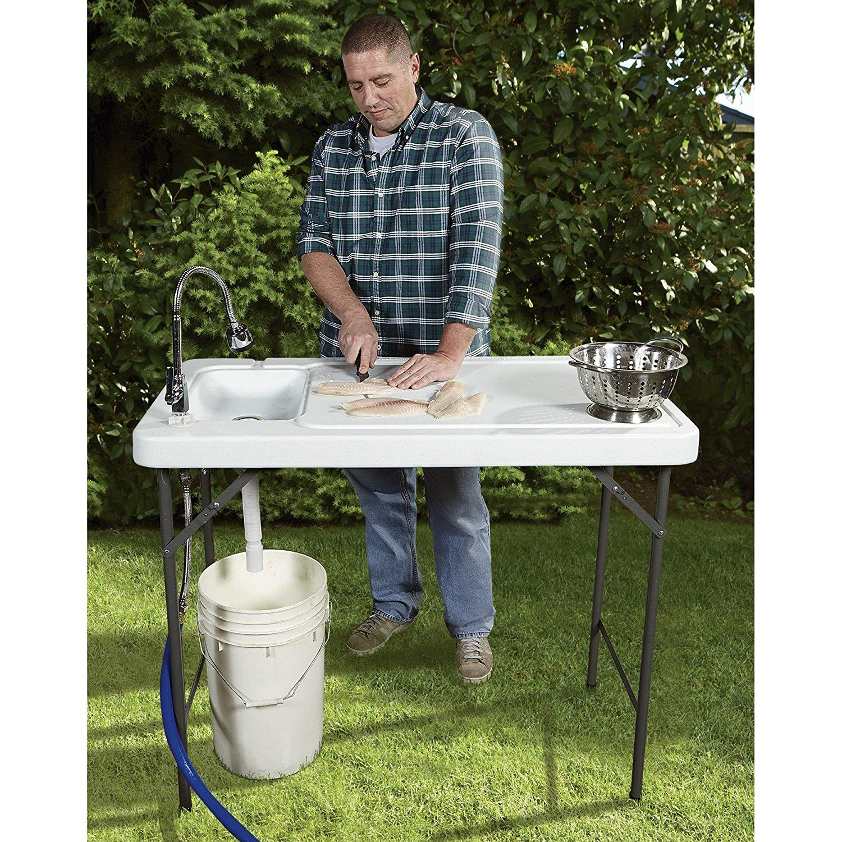

***ALL******Outdoor Showers and fish cleaning stations need a permit & an inspection per District Policy. We are actively identifying these to insure we do not have an excess of rainwater in our sewer system. The smoke testing did help us with these. Please***

***call the***

***District office @***

***361-983-2652 to obtain the required permit.***



**If you are closing your account, you must call the office and do so. You will continue to receive a bill until it is closed.**

**The buyer cannot close your account**.



**Auto Draft Fee Waived**

Those of you who have been utilizing the ACH payment option, there is NO CHANGES NEEDED ON YOUR PART and you will see, on your next statement, that the fee has been removed. If any of our customers would like to start using this payment option:

* Go to the website @ [www.pocid.org](https://l.facebook.com/l.php?u=http%3A%2F%2Fwww.pocid.org%2F%3Ffbclid%3DIwAR1RcLWgEPAebm-ZNp70EGMkdf6QCoy3I49g8QBfZVBynTieC7M20Sd3RQk&h=AT1Prcf9xoYbUFAOUcPOxbg7MUs3wGQteTOXAnPb0XsyQCf_6nsq8S0ZLhR6gLylSJ80jN-WzzwV6QRPV52KfYSAijxP7_rrHN-19yrmajQQWAYzCSAZEvriyvu3Vy86IA&__tn__=-UK-R&c%5b0%5d=AT0It4OKA8z8brbuTEnJqAzCMRBHMWLw_RM2miWdY3o9svX_12_RvDSSq26YlU-s4v5tTlpPMHOUpK6s8jjULL9C2sIy7JIpjBjH7NA7aYPhlrnfv6gpcwlxJ7UoVdNXPbOcIl0SqPXJ6ooseBqevuzRmBexfu8PNPwqE-P6XUSBxA) - select Bill Payment and log in or set up an account and then select I want to set up auto pay.

* Go online to [https://www.pocid.org/all-forms](https://www.pocid.org/all-forms?fbclid=IwAR0ESAVw63Q2_aWjDFNmgcVcvFVRqAQk7sO08dwwTp0zozGdy7qZCfYrRZc) and select POCID ACH & Credit Card Form then fill out a form and email it to www.pocid@pocid.org

* Contact the Port O'Connor Improvement Office at 361-983-2652



**Irrigation Permits**

**All sprinkler systems require a permit completed and turned in to the POCID Office before installation. After installation a backflow inspection is required.**

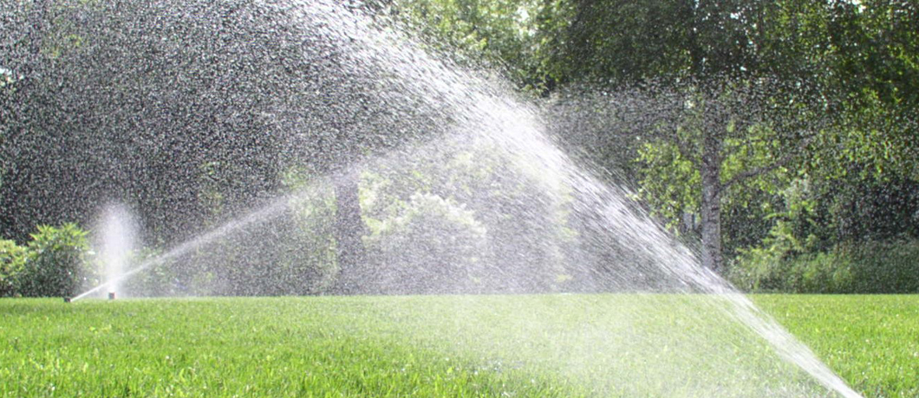

Check out our Website @ [www.pocid.org](http://www.pocid.org)

**\*Sign up for Alerts**

**\* Pay your bill**

**\* Applications/Forms**

**\* Sign up for Auto Draft**

**\* Current Projects**

**\* Agendas/Minutes**

**\* Updates**

**\* Sign up for paperless billing**