- Monthly Newsletter  July 2022  Important Dates:  POC Water Board Meetings are held on the third Thursday of each month @ 1pm  July 21st * August 18th  Roll off Trash Bin  First Saturday of each month behind the POCID Office from 8am -2pm or UNTIL FULL  July 9th * August 6th  Billing  Bills are mailed by the 1st  of each month and are due  on 20th of every month  and a late fee will be assessed  on the 21st unless that falls  on a weekend and then it  will be due the following  Monday.  Payment Methods:  Credit Card*Mail*Automatic  Bank Draft*Automatic Credit Card Draft*In Person*Payment Drop  Box* Bill Pay through your  Financial Institute  - Contact Us  POCID  39 Denman DR  PO Box 375  Port O’Connor, Texas 77982  361-983-2652  pocid@pocid.org  https://www.pocid.org/  https://www.facebook.com/POCIDofficial/  Vision Statement  POCID is a proactive organization making a positive impact on the community while implementing best management practices to promote sustainable success.  Mission Statement  To proactively and efficiently  manage the affairs of the District  for the benefit of its customers,  protect the health of the community, produce safe drinking water in adequate quantities, offer  competitive rates, assure  financial stability, and practice excellence in customer service. | “POCID”  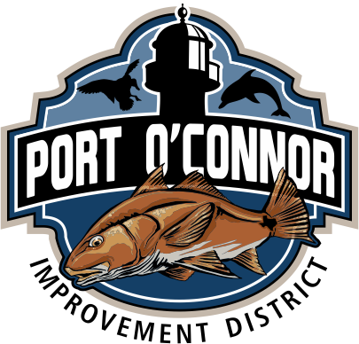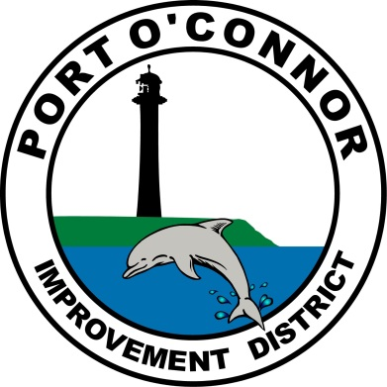  BOARD POSITION FILLED  On Tuesday, June 21, 2022 Board of Director member David Randolph submitted his resignation to the District’s Board of Directors. Mr. Randolph has served on the Board of Directors for almost 4 years, having been appointed in 2018 and re-elected in November of 2020. David served during a period of great change from instability to a cohesive forward-looking board that focuses on what is best for the community. His perseverance and dedication during this transition is greatly appreciated. We are extremely grateful for his time and service to the District and this community and we wish him the best in all of his future endeavors.  Mr. Randolph’s resignation left a vacancy on the Board that needed to be filled. The Board of Directors met via a special meeting on Tuesday, June21, 2022 to address the vacancy. Since Victor Mozisek had been in regular attendance as a member of the public at Board meetings, he was approached to gauge his interest in the position. Mr. Mozisek agreed to serve as a Director and was appointed to fill the position. We thank Mr. Mozisek for agreeing to serve and welcome him to the POCID Board of Directors.  Grease Trap or no Grease Trap  Often-times when it comes to small restaurants or eateries the question comes up, do I or do I not need a grease trap. The answer to that is yes if you are doing any cooking on-site.  Keeping Fats, Oil and Grease (FOG) out of the sewer system is a concern for TCEQ and more information on prevention is available on their Take Care of Texas resources page.  The Port O’Connor Improvement District has a Grease Discharge Rule that outlines what the procedures are for the proper installation, maintenance, and inspections of all grease traps.  Improperly maintained grease traps will create problems with the vacuum pits/buffer tanks, sewer mains and customer laterals.  District personnel will be inspecting grease traps periodically to keep our system FOG free. If you are a commercial customer and are not sure if you do or don’t need a grease trap, please contact the District office at 361-9832652.  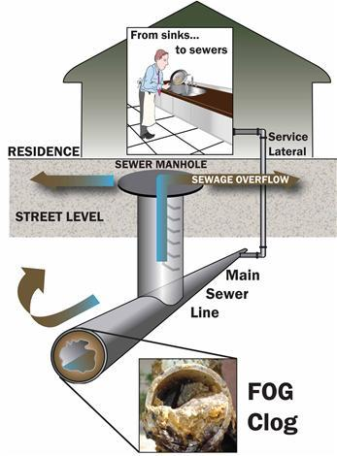

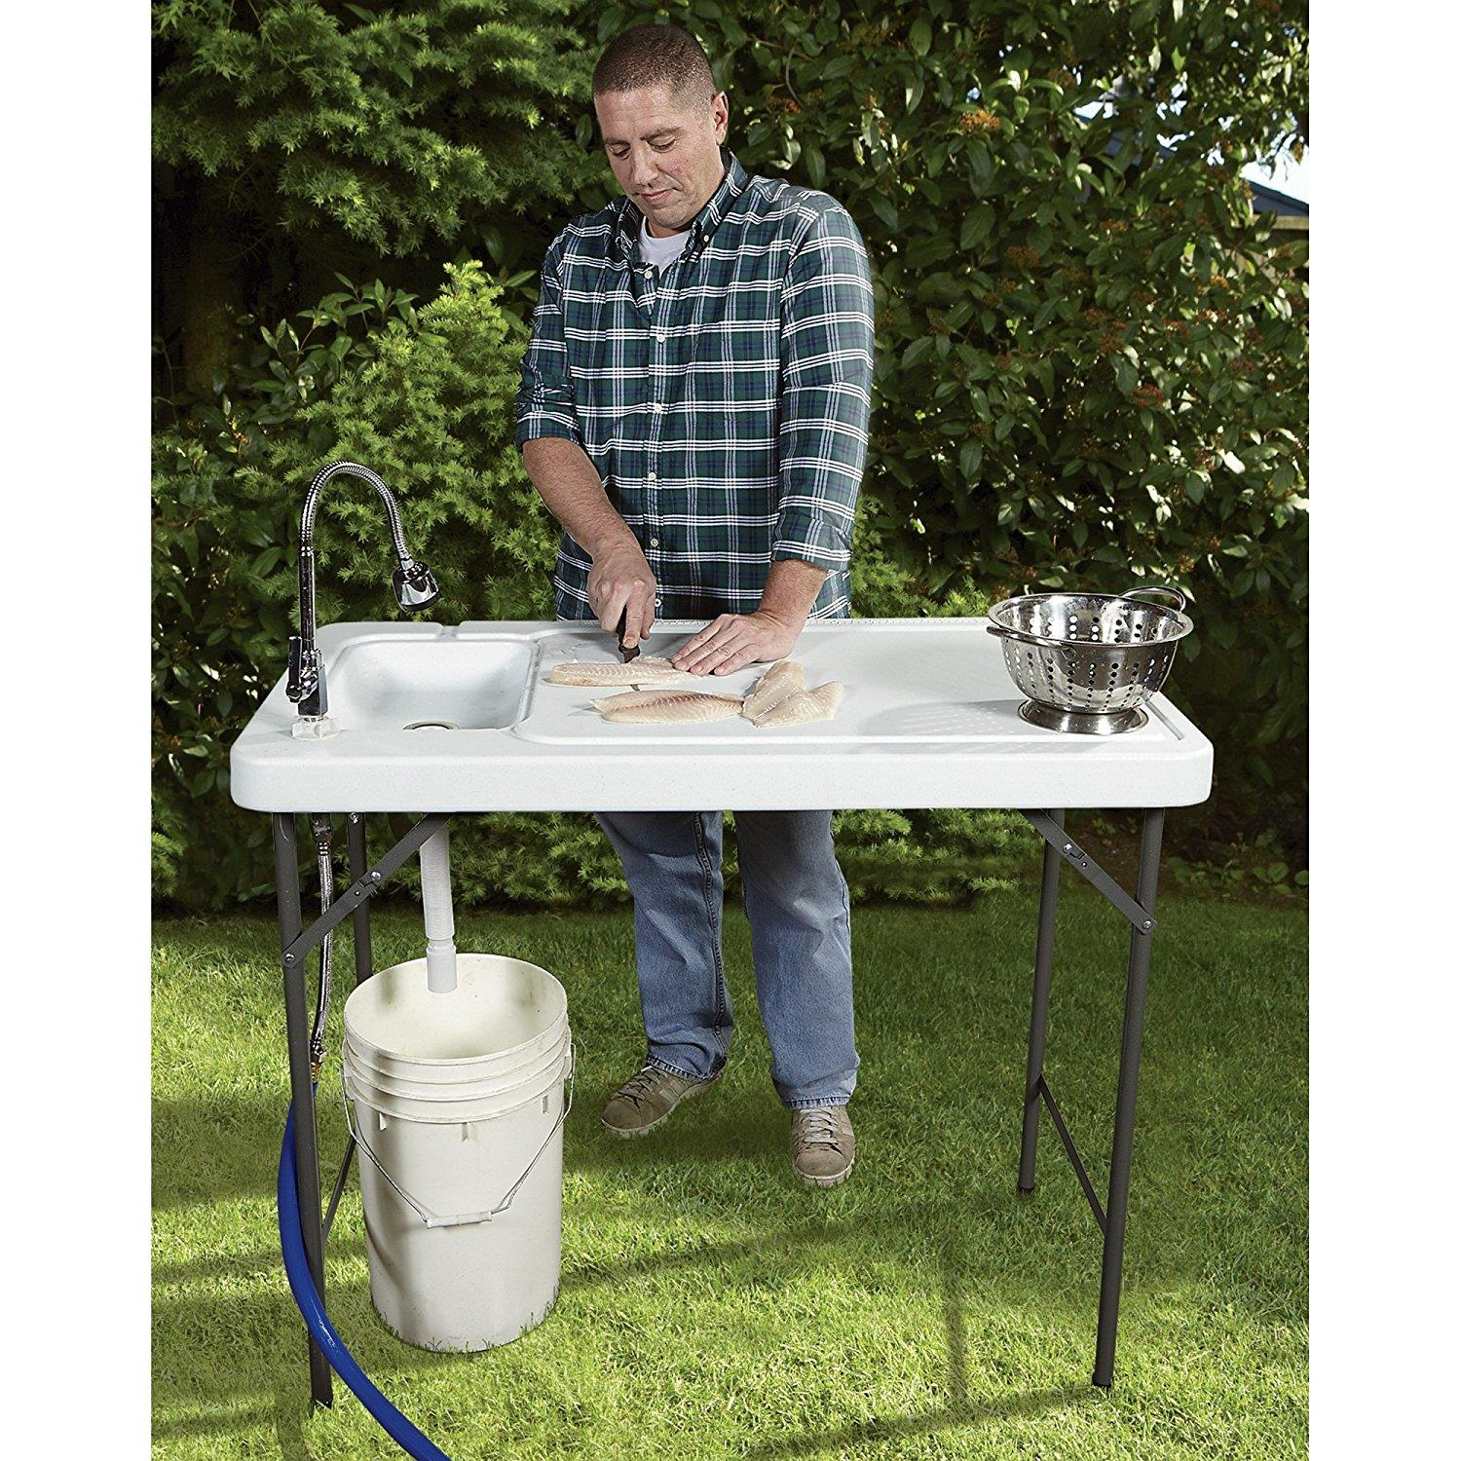
ALL Outdoor Showers and fish cleaning stations need a permit & an inspection per District Policy. We are actively identifying these to insure we do not have an excess of rainwater in our sewer system. The smoke testing did help us with these. Please
call the
District office @
361-983-2652 to obtain the required permit.

If you are closing your account, you must call the office and do so. You will continue to receive a bill until it is closed.
The buyer cannot close your account.
Auto Draft Fee Waived

Those of you who have been utilizing the ACH payment option, there is NO CHANGES NEEDED ON YOUR PART and you will see, on your next statement, that the fee has been removed. If any of our customers would like to start using this payment option:
* Go to the website @ www.pocid.org - select Bill Payment and log in or set up an account and then select I want to set up auto pay.
* Go online to https://www.pocid.org/all-forms and select POCID ACH & Credit Card Form then fill out a form and email it to www.pocid@pocid.org
* Contact the Port O'Connor Improvement Office at 361-983-2652
Irrigation Permits
All sprinkler systems require a permit completed and turned in to the POCID Office before installation. After installation a backflow inspection is required.
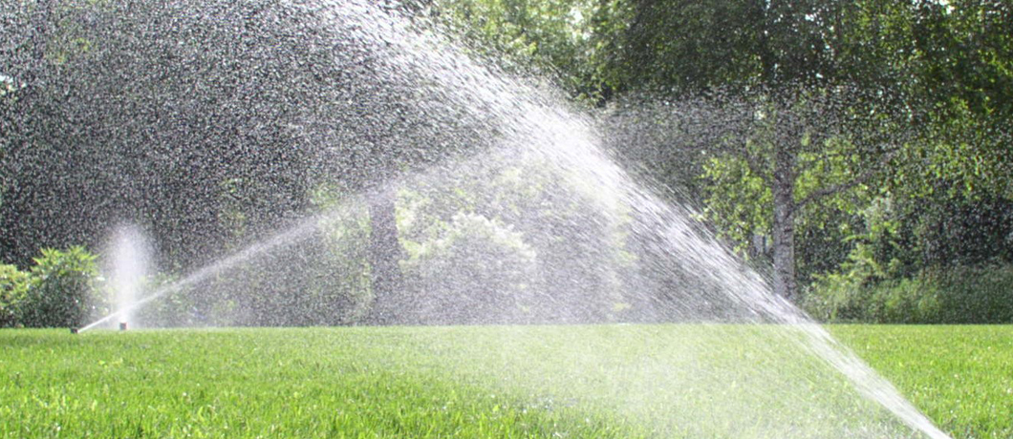
Check out our Website @ www.pocid.org
*Sign up for Alerts
* Pay your bill
* Applications/Forms
* Sign up for Auto Draft
* Current Projects
* Agendas/Minutes
* Updates
* Sign up for paperless billing

