|  |  |  |  |  |
| --- | --- | --- | --- | --- |
| |  | | --- | | Monthly Newsletter  September 2023 | | |  | | --- | | Important Dates:  **POC Water Board Meetings are held on the third Thursday of each month @ 1pm**  *October 19th * November 16th * December 21st * January 18th*  **Roll off Trash Bin**  **First Saturday of each month behind the POCID Office from 8am -2pm or UNTIL FULL**  *October 7th * November 4th * December 2nd * January 6th* | |   **Billing**  ***Bills are mailed by the 1st***  ***of each month and are due***  ***on 20th of every month***  ***and a late fee will be assessed***  ***on the 21st unless that falls***  ***on a weekend and then it***  ***will be due the following***  ***Monday.***  **Payment Methods:**  *Credit Card*Mail*Automatic*  *Bank Draft*Automatic Credit Card Draft*In Person*Payment Drop*  *Box* Bill Pay through your*  *Financial Institute*  Contact Us  POCID  39 Denman DR  PO Box 375  Port O’Connor, Texas 77982  361-983-2652  pocid@pocid.org  <https://www.pocid.org/>  <https://www.facebook.com/POCIDofficial/>  **Vision Statement**  *POCID is a proactive organization making a positive impact on the community while implementing best management practices to promote sustainable success.*  **Mission Statement**  *To proactively and efficiently*  *manage the affairs of the District*  *for the benefit of its customers,*  *protect the health of the community, produce safe drinking water in adequate quantities, offer*  *competitive rates, assure*  *financial stability, and practice excellence in customer service.* | **“POCID”**      **2023 TAX RATE SET**  On Wednesday, September 6, 2023, the Board of Directors met to conduct the public hearing and then to adopt the tax rate for 2023. The new rate is $0.4949 per $1oo of valuation. This is a decrease from the 2022 rate of $0.5050. Whether your taxes increase or decrease depends on your individual circumstances. If the value of your property is lower or remains unchanged, whether because of over 65 value freezes or other factors, then your taxes will decrease. If your property increased in value, then your taxes will increase. This rate consists of two components: $0.22 to pay the District’s debt service on all outstanding tax based bonds and $0.2749 to fund the District’s maintenance and operation expenditures. Property within Defined Area No. 1 (Caracol) has an additional ad valorem tax of $0.5051 levied to provide for maintenance and operations purposes specifically related to the Defined Area No. 1.  How are these rates set? Setting the tax rate is part of the budget process. After the budget is adopted, the financial advisors of the District are consulted to recommend a tax rate. The advisors determine the amount of taxes necessary to fund the District’s debt service and then how much is necessary to meet the maintenance and operations needs of the District. The financial advisors make a final recommendation to the Board of Directors. The Board takes their advice under consideration and establishes a proposed tax rate and sets the public hearing date for the proposed rate. The law requires notice of this posting be placed in an ad in a newspaper in general circulation within the District. The District placed the required ad in the Port Lavaca Wave. Additionally, the District placed the notice on its website and posted the notice on its Facebook page to provide additional notice to its customers. After the public hearing the Board votes on the final tax rate and submits an order levying the taxes to the appraisal district.  As stated in the public information sessions held prior to the bond election, the new bonds that were issued in August to finance district improvements did not increase the tax rate.  **DISTRICT FINANCIAL CHANGES AND BOND ISSUANCES**  In January of 2023 the Board hired Masterson Advisors LLC (“Masterson”) out of Houston to advise on future bond issuance as the District’s financial advisor. After a review of the District’s records and financials, Masterson advised the Board of Directors to consider pursuing an underlying credit rating from Moody’s Investors Service, which would reduce the rate of interest paid by the District on the proposed 2023 Bonds. Masterson felt the improvements the Board had made in District operations and management in the past few years, the overall financial health of the District, and the fact that all TCEQ mandates had been fulfilled would enable the District to obtain a favorable rating. The Board of Directors voted to proceed with obtaining an underlying credit rating. Masterson filed all the necessary documentation and later informed the Board that the District had received a favorable A3 rating. This is a great accomplishment and a statement by Moody’s Investors Service that the District is considered a highly rated credit that investors can rely upon.  Masterson’s predictions of cost savings on future bond issuances due to this rating were promptly proven correct. On August 17, 2023, the District closed on the issuance of $15,280,000 (the “2023 Series”) of the $40,000,000 bonds approved by the voters at the May 7, 2022 bond election. According to Masterson, the underlying credit rating saved the District approximately 50 basis points (0.50%) in interest expense on the Series 2023 Bonds compared to other issuers without a rating who sold bonds in the general time period of the District’s sale. The 2023 Series bonds were sold with a net effective interest rate of 4.567864%. These bonds will mature serially (annually) 2025 through 2057.  Proceeds of the 2023 Bond sale will be used for the improvements itemized below. These costs and projects were compiled by BGE, Inc., the District’s engineer (the “Engineer”) and were submitted to TCEQ in the District’s Bond Application and approved by the TCEQ.    The District’s total debt payable from taxes after issuance of the 2023 Bonds is $26,870,000 principal amount. As a result of growth in the 2023 taxable value to $665,061,176 from $549,864,648 and the reduced interest expense on the 2023 Bonds, the District was able to incur the new debt and reduce the 2023 debt service tax rate to $0.22 and the total tax rate to $0.4949. The District’s total debt service is structured to be generally level or declining with an average annual debt service of $1,415,812 (2024-2057). |

**CHANGE IN NEWSLETTER DISTRIBUTION**

Due to increases in printing and postage, the Board of Directors has elected to change the newsletter from monthly distribution to a quarterly issuance to better utilize the District’s resources; therefore, the next issue will be in January of 2024.  The District will continue to post relevant information on its website and via the District’s social media outlets to keep customers up to date on District events.  As always, if you have any questions, please contact the District office.



**Irrigation Permits**

**All sprinkler systems require a permit completed and turned in to the POCID Office before installation. After installation a backflow inspection is required.**

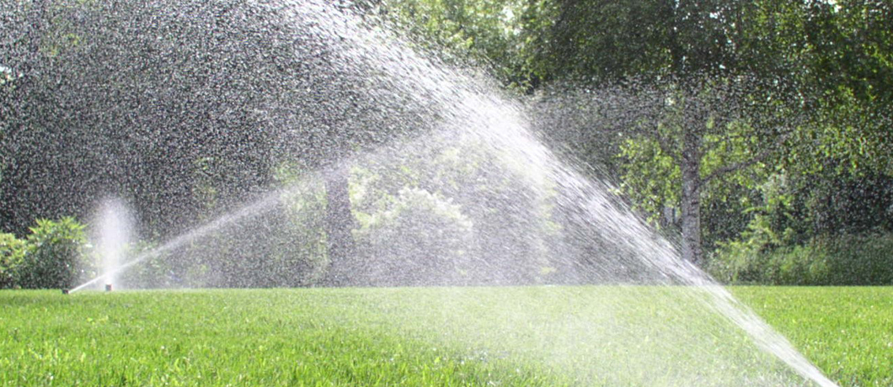

Check out our Website @ [www.pocid.org](http://www.pocid.org)

**\*Sign up for Alerts**

**\* Pay your bill**

**\* Applications/Forms**

**\* Sign up for Auto Draft**

**\* Current Projects**

**\* Agendas/Minutes**

**\* Updates**

**\* Sign up for paperless billing**

**POCID Rules and Regulations require all customers to have a customer service valve outside their meter box within 3 feet of the meter box.**

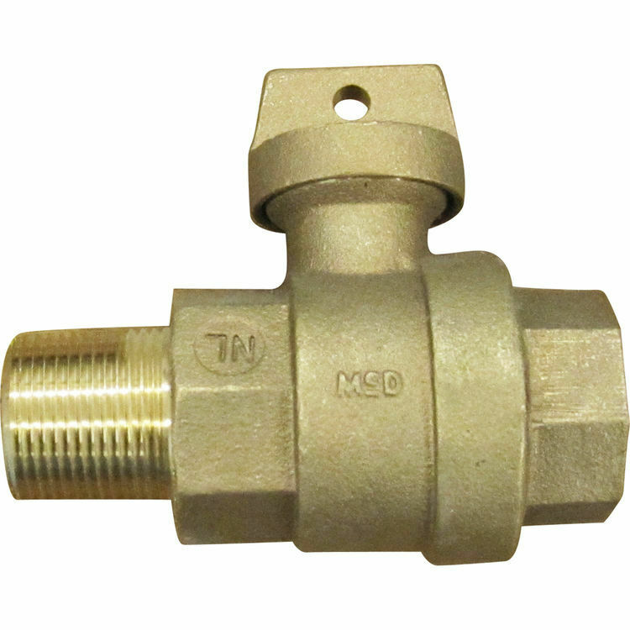



**Auto Draft Fee Waived**

Sign up for Auto Draft with your **Bank Account** for **NO FEE**!! **Please note that if you use your Credit Card there is a 3.5% fee.**

* Go to the website @ [www.pocid.org](https://l.facebook.com/l.php?u=http%3A%2F%2Fwww.pocid.org%2F%3Ffbclid%3DIwAR1RcLWgEPAebm-ZNp70EGMkdf6QCoy3I49g8QBfZVBynTieC7M20Sd3RQk&h=AT1Prcf9xoYbUFAOUcPOxbg7MUs3wGQteTOXAnPb0XsyQCf_6nsq8S0ZLhR6gLylSJ80jN-WzzwV6QRPV52KfYSAijxP7_rrHN-19yrmajQQWAYzCSAZEvriyvu3Vy86IA&__tn__=-UK-R&c%5b0%5d=AT0It4OKA8z8brbuTEnJqAzCMRBHMWLw_RM2miWdY3o9svX_12_RvDSSq26YlU-s4v5tTlpPMHOUpK6s8jjULL9C2sIy7JIpjBjH7NA7aYPhlrnfv6gpcwlxJ7UoVdNXPbOcIl0SqPXJ6ooseBqevuzRmBexfu8PNPwqE-P6XUSBxA) - select Bill Payment and log in or set up an account and then select I want to set up auto pay.

* Go online to [https://www.pocid.org/all-forms](https://www.pocid.org/all-forms?fbclid=IwAR0ESAVw63Q2_aWjDFNmgcVcvFVRqAQk7sO08dwwTp0zozGdy7qZCfYrRZc) and select POCID ACH & Credit Card Form then fill out a form and email it to [www.pocid@pocid.org](http://www.pocid@pocid.org)

* Call 844-923-2162 and pay your bill by phone 24/7

* Contact the Port O'Connor Improvement Office at 361-983-2652

