- Monthly Newsletter  March 2021  Important Dates:  POC Water Board Meetings are held on the second Thursday of each month @ 1pm  March 11th * April 15  Roll off Trash Bin  First Saturday of each month behind the POCID Office from 8am -2pm or UNTIL FULL  March 6th  April 3rd * May 1st  Billing  Bills are mailed by the 1st  of each month and are due  on 20th of every month  and a late fee will be accessed  on the 21st unless that falls  on a weekend and then it  will be due the following  Monday.  Payment Methods:  Credit Card*Mail*Automatic  Bank Draft*Automatic Credit Card Draft*In Person*Payment Drop  Box* Bill Pay through your  Financial Institute  - Contact Us  POC Water  39 Denman DR  PO Box 375  Port O’Connor, Texas 77982  361-983-2652  pocmud@tisd.net  https://www.pocid.org/  https://www.facebook.com/POCIDofficial/  Vision Statement  POCID is a proactive organization making a positive impact on the community while implementing best management practices to promote sustainable success.  Mission Statement  To proactively and efficiently  manage the affairs of the District  for the benefit of its customers,  protect the health of the community, produce safe drinking water in adequate quantities, offer  competitive rates, assure  financial stability, and practice excellence in customer service. | “POC Water”  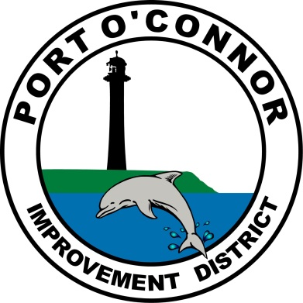  P.O. Box 375/ 39 Denman Dr  Port O’ Connor, Texas 77982  Phone: (361) 983-2652  Smart Water, Smart Metering  Advanced Metering Infrastructure (AMI), or ‘Smart Meters’, is a two-way solution in which a network is created between the meters and the District. In order to increase efficiency and to maintain optimal standards, the District will be installing Smart Meters in the near future. There are many advantages to Smart Meters for both the District and the customer. From the District’s side, Smart Meters provide multiple benefits including leak detection. From the customer’s side, Smart Meters can provide information on when/where is water being used, comparisons of own water use against the District average use, and quick leak detection.  Two beneficial aspects of turning to Smart Meters for the District include the following: (1) the reduction of water losses in the system; and (2) the enhancement of demand management strategies. First, non-revenue water - which is the difference between what is pumped, treated, and supplied to the distribution system compared to what reaches customers - can be up to 20% or more of the total water inventory. Keeping this unaccounted for water percentage as low as possible increases the efficiency of the system and reduces the cost of water. Smart Meters help to better detect water losses. Second, on the demand side, Smart Meters can be used to enhance demand management strategies, where demand management involves the better use of existing water supplies before plans are made to further increase supply. Specifically, demand management promotes water conservation both in times of normal and atypical conditions through changes in people’s practices and attitudes towards water resources.  For the customers, Smart Meters enable water utilities to conduct regular meter reads of customers throughout the day provide customers with real-time water consumption data so they can determine if they have a leak. Smart Meters will enable a customer to quickly detect water losses and, as a result, avoid large bills due to undetected leaks. This data can also be used to raise awareness of water consumption and allow customers to develop their own strategies to reduce water usage.  In conclusion, the District’s use of Smart Meters will allow the District to increase operational efficiency, more adequately determine water needs—including future needs, help develop water conservation plans, detect leaks, and to better monitor the system. For customers, Smart Meters can be used by the District to provide customers with historical data as well as a breakdown of consumption processes that use water, help customers identify water efficiencies in homes, set water saving goals, and alert customers to possible leaks.  Happy St Patrick’s Day from your friendly POCID Crew!  PROJECT UPDATE  TWDB Project No. 21750  All the work that was originally designed by Brown and Gay and the work from change orders to the project has been completed. The balance of the funds remaining are being used to perform a valve & hydrant inventory & evaluation.  2016 TWDB Projects  Completed projects  Vacuum Station No. 2 Force Main  Vacuum Sewage Collection System Upgrade  Phase II Water System Improvements  Ongoing projects:  Phase III Water & Sewer System Improvements  Miscellaneous water & sewer improvements are under design  2020 TWDB DW SRF Bond Projects  Final environmental submittals have been made to TWDB. TWDB has indicated that it will be the first part of 2021 before their review and approval will be completed. The projects cannot be put out for bids until TWDB has approved all the environmental. A public hearing on the environmental was held on December 10, 2020.  New Water Wells  The plans for the water wells have been completed and approval from TCEQ was received by letter dated 6/22/20. A resubmittal for the new Well No 7 has been summitted to TCEQ for approval of the new well location. The proposed water wells will be submitted to the Calhoun County GCD for drilling & operation permits at their next meeting to be held on March 22, 2021.  Well Transmission Lines and RO Outfall  The plans for the well lines and RO discharge line are nearing completion subject to a revision to include the line to the new Well No. 7 location. Plans have been summitted to TCEQ for review & approval.  Raw Water Ground Storage Tank  The plans and specifications for this project are complete and were approved by TCEQ by letter dated 6/2/20. A revised submittal is being developed for a larger raw water storage tank based on design re-consideration with the inclusion of LaSalle to the water distribution system. Formal approval will not be given by TWDB until all environmental conditions have been met.  Reverse Osmosis Treatment Facility  Design for this major project is proceeding. This is a major design project that includes a building, equipment, piping, electrical, controls, HVAC and chemical treatment.  The original design concept is being modified due to the inclusion of LaSalle to the system. The RO capacity has been increased & the building has been increased in size to accommodate the additional equipment.  None of the 2020 Bond projects can be bid until all the environmental and permitting has been completed and approved by TWDB. For TWDB to approve the completed Environmental Document the following are required.  - Final design of all project components (See individual Project status above)  - Engineering Feasibility Report (Completed and in Application)  - Public meeting (held on Dec 10)  There will then be an approximate three-month time for review and approval by TWDB, provided there are no major problems with any of the submittals.  Because the wells will take the longest time for approval, at least 60 days after they are completed, the wells will be the first project of the 2020 Bond fund projects to bid. Bidding of the other projects will be staged as appropriate depending on the time required for completion of the wells and to minimize on-site conflicts with multiple projects and contractors.  Elevated Storage Tank  This has been placed on hold until completion of the District Master Plan in order to better determine the needs of the District for water storage facilities.  Easement acquisitions  An exception to the sanitary control easement area that falls within the TXDOT RROW for SH185 still must be obtained from TCEQ. The revised and enlarged R/O outfall line easement has been obtained. The sanitary control easement necessary for Well #7 has been drafted and is awaiting execution.
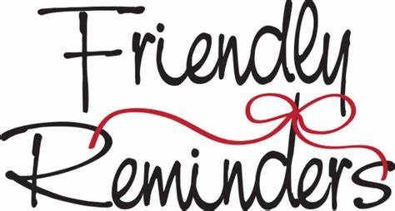
IF YOU HAVE ONE OF THESE
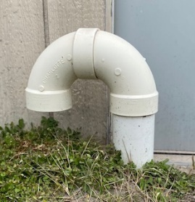
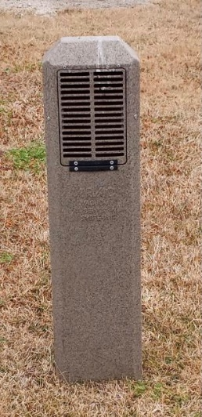
YOU DON’T NEED THIS

Is your account a TEMP account? Call us to schedule a for Customer Service Inspections (CSI) to be in compliance with the state. This is to make sure you don't have any lead pipes or cross connections.

Letter from the President!
This letter comes to you post winter storm Uri. We survived but didn’t come out unscathed. Our community as well as the rest of the state was hammered with brutal cold, high wind, loss of electricity, loss of water, broken pipes, dead trees, dead plants and other damages too numerous to list.

The district offices, property and employees didn’t escape damage either. All pipes in the office burst and office personnel used buckets to flush the toilet while they worked to provide service to our customers. Several pieces of equipment failed and gauges froze. District personnel had their personal homes suffer broken pipes and other damage. During the storm the POCID team insured the community was taken care of before they addressed their own damages. It is the responsibility of the Board, Management and Personnel to ensure our customer are our first priority. We take this responsibility seriously and we hope that was shown during this winter storm.

We also cannot go without showing our tremendous gratitude to the POC community! We had no less than 20 of our community members help during the bitter cold to shut off water to observed leaks and customer requests. We cannot thank you enough for your help and support!
We also want to thank the community as a whole! We received tremendous support from hundreds of folks who just wanted to say thanks and show appreciation. This does not go unnoticed or under appreciated. We want to single out and thank Mr. Patel from the America Inn who came in and paid for lunch for the entire staff during the storm.

POCID, after losing water and issuing a boil water notice, was one of the first in this area of the state to restore service and rescind the boil water notice. This states volumes about the leadership of our District Manager, Oscar Pena, and our tremendously dedicated and talented POCID staff.

District personnel held an after-action meeting to set out the timeline of the storm and action plan to resolve and mitigate issues that arose from the storm. The results of that meeting are posted on the district website.

In closing this letter, I just want to state how grateful and lucky I feel to be part of this awesome community and part of such a phenomenal group of dedicated folks at POCID!

Danny McGuire
POCID Board President
Check out our Website @ www.pocid.org
*Sign up for Alerts
* Pay your bill
* Applications/Forms
* Sign up for Auto Draft
* Current Projects
* Agendas/Minutes
* Updates
* Sign up for paperless billing

Customer Service Valve
Remember to install a customer service valve on your side of the meter. Please turn your customer service valve off if you live out of town to keep any water leaks turning into a disaster. Turning on/off the POCID meter is against District Policy.
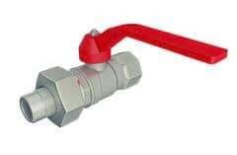

The biggest reason why a fire hydrant would be flushed is to clear out any stagnant water that may be sitting in the District’s pipes. When water is pumped through district pipelines, it is treated with chlorine to keep bacteria from thriving in it.

POC Water
PO Box 375/39 Denman Dr
Port O’Connor, TX 77982
361-983-2652

