PORT O’CONNOR IMPROVEMENT DISTRICT
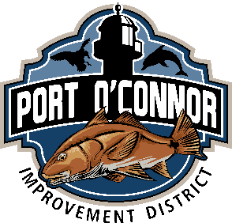
SERVICE INQUIRY

DATE ISSUED TO DATE COMPLETED
CUSTOMER PHONE
ADDRESS
LOT BLK

DESCRIPTION OF PROPERTY
SEWER WATER
EXTENTION YES OR NO
NOTES
DIAGRAM OF LINES ON CCAD MAP ATTACHED

