|  |  |  |  |  |
| --- | --- | --- | --- | --- |
| |  | | --- | | Monthly Newsletter  November 2022 | | |  | | --- | | Important Dates:  **POC Water Board Meetings are held on the third Thursday of each month @ 1pm**    *November 17 * December 15*  **Roll off Trash Bin**  **First Saturday of each month behind the POCID Office from 8am -2pm or UNTIL FULL**  *November 5th * December 3rd* | |   **Billing**  ***Bills are mailed by the 1st***  ***of each month and are due***  ***on 20th of every month***  ***and a late fee will be assessed***  ***on the 21st unless that falls***  ***on a weekend and then it***  ***will be due the following***  ***Monday.***  **Payment Methods:**  *Credit Card*Mail*Automatic*  *Bank Draft*Automatic Credit Card Draft*In Person*Payment Drop*  *Box* Bill Pay through your*  *Financial Institute*  Contact Us  POCID  39 Denman DR  PO Box 375  Port O’Connor, Texas 77982  361-983-2652  pocid@pocid.org  <https://www.pocid.org/>  <https://www.facebook.com/POCIDofficial/>  **Vision Statement**  *POCID is a proactive organization making a positive impact on the community while implementing best management practices to promote sustainable success.*  **Mission Statement**  *To proactively and efficiently*  *manage the affairs of the District*  *for the benefit of its customers,*  *protect the health of the community, produce safe drinking water in adequate quantities, offer*  *competitive rates, assure*  *financial stability, and practice excellence in customer service.* | **“POCID”**      **NEW OPTIONAL DONATION FOR POC VOLUNTEER FIRE DEPARTMENT**  At the September monthly meeting the board asked that an item be placed on the October meeting agenda for the Board of Directors to consider adding an optional monthly donation to the Port O’Connor Volunteer Fire Department on all customer water bills.   The District’s acting general manager brought it to the Board’s attention that other districts have an opportunity to donate line item on the customer’s water bill for fire departments.  It is up to the customer to opt out of the donation.  At the October meeting, the Port O’Connor Improvement District’s Board of Directors voted to include this provision on future customer water and wastewater bills.  Please note, that action is required if you elect NOT to donate.  This is an opt out selection.  If no action is taken the donation will be automatically included in your water bill payment.  An example of what this will look like on your bill is included below.  To “opt out” the customer will need to contact the District’s office and ask that this line item be removed from their bills.  If you have not opted out and later desire to do so, please contact the District’s office to ask that the donation line item be removed and reduce the total payment showing due for that month by two ($2) dollars.  The below provided sample section of the customer’s bill depicts how the donation will appear as a separate line item and be included in the total amount due the District. Again, if a customer wishes to opt out of the donation, then he or she must contact the District’s office.    If a customer elects to pay the entire amount due, then the donation will be allocated to the Port O’Connor Volunteer Fire Department.  Every month the District will write a check for the amount of funds collected via customer donations and present it to the fire department.  The Board feels the fire department is an invaluable asset and would like to make it easier and more convenient for the community to support the organization.  As already stated, any contributions would be purely voluntary.  No customer’s service will be impacted by a failure to participate in the voluntary donation opportunity.  The January 2023 water bills will be the first to have this optional donation included on them.  If anyone has any questions, please contact the District’s office.  Sample water bill with donation included:        The District is adding 5 new fire hydrants to the water line on the south side of Hwy 185 between Scurlock and Steve Street. This is one of the goals of the district to provide better fire protection to the community. |

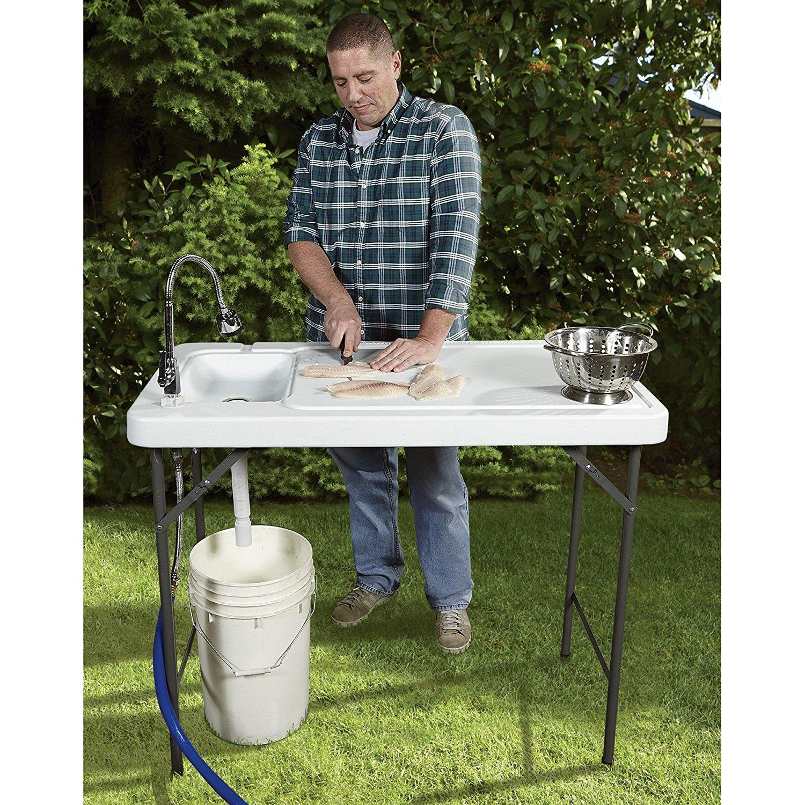

***ALL******Outdoor Showers and fish cleaning stations need a permit & an inspection per District Policy. We are actively identifying these to insure we do not have an excess of rainwater in our sewer system. The smoke testing did help us with these. Please***

***call the***

***District office @***

***361-983-2652 to obtain the required permit.***



**If you are closing your account, you must call the office and do so. You will continue to receive a bill until it is closed.**

**The buyer cannot close your account**.



**Auto Draft Fee Waived**

Sign up for Auto Draft with your **Bank Account** for **NO FEE**!! **Please note that if you use your Credit Card there is a 3.5% fee.**

* Go to the website @ [www.pocid.org](https://l.facebook.com/l.php?u=http%3A%2F%2Fwww.pocid.org%2F%3Ffbclid%3DIwAR1RcLWgEPAebm-ZNp70EGMkdf6QCoy3I49g8QBfZVBynTieC7M20Sd3RQk&h=AT1Prcf9xoYbUFAOUcPOxbg7MUs3wGQteTOXAnPb0XsyQCf_6nsq8S0ZLhR6gLylSJ80jN-WzzwV6QRPV52KfYSAijxP7_rrHN-19yrmajQQWAYzCSAZEvriyvu3Vy86IA&__tn__=-UK-R&c%5b0%5d=AT0It4OKA8z8brbuTEnJqAzCMRBHMWLw_RM2miWdY3o9svX_12_RvDSSq26YlU-s4v5tTlpPMHOUpK6s8jjULL9C2sIy7JIpjBjH7NA7aYPhlrnfv6gpcwlxJ7UoVdNXPbOcIl0SqPXJ6ooseBqevuzRmBexfu8PNPwqE-P6XUSBxA) - select Bill Payment and log in or set up an account and then select I want to set up auto pay.

* Go online to [https://www.pocid.org/all-forms](https://www.pocid.org/all-forms?fbclid=IwAR0ESAVw63Q2_aWjDFNmgcVcvFVRqAQk7sO08dwwTp0zozGdy7qZCfYrRZc) and select POCID ACH & Credit Card Form then fill out a form and email it to [www.pocid@pocid.org](http://www.pocid@pocid.org)

* Contact the Port O'Connor Improvement Office at 361-983-2652



**Irrigation Permits**

**All sprinkler systems require a permit completed and turned in to the POCID Office before installation. After installation a backflow inspection is required.**

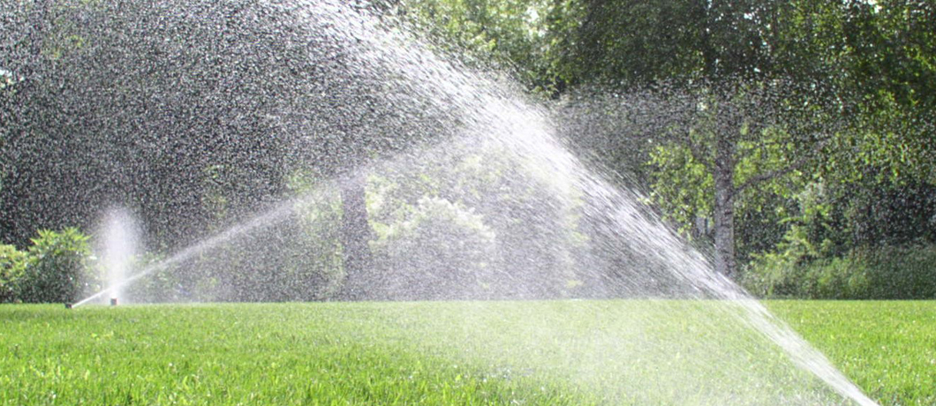

Check out our Website @ [www.pocid.org](http://www.pocid.org)

**\*Sign up for Alerts**

**\* Pay your bill**

**\* Applications/Forms**

**\* Sign up for Auto Draft**

**\* Current Projects**

**\* Agendas/Minutes**

**\* Updates**

**\* Sign up for paperless billing**