- Monthly Newsletter  October 2022  Important Dates:  POC Water Board Meetings are held on the third Thursday of each month @ 1pm  October 20th * November 17th  Roll off Trash Bin  First Saturday of each month behind the POCID Office from 8am -2pm or UNTIL FULL  October 1st * November 5th  Billing  Bills are mailed by the 1st  of each month and are due  on 20th of every month  and a late fee will be assessed  on the 21st unless that falls  on a weekend and then it  will be due the following  Monday.  Payment Methods:  Credit Card*Mail*Automatic  Bank Draft*Automatic Credit Card Draft*In Person*Payment Drop  Box* Bill Pay through your  Financial Institute  - Contact Us  POCID  39 Denman DR  PO Box 375  Port O’Connor, Texas 77982  361-983-2652  pocid@pocid.org  https://www.pocid.org/  https://www.facebook.com/POCIDofficial/  Vision Statement  POCID is a proactive organization making a positive impact on the community while implementing best management practices to promote sustainable success.  Mission Statement  To proactively and efficiently  manage the affairs of the District  for the benefit of its customers,  protect the health of the community, produce safe drinking water in adequate quantities, offer  competitive rates, assure  financial stability, and practice excellence in customer service. | “POCID”  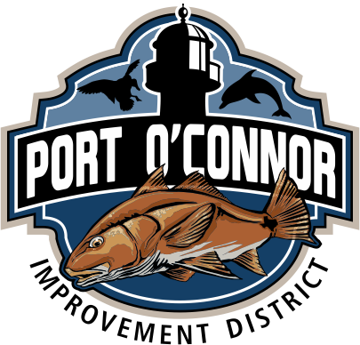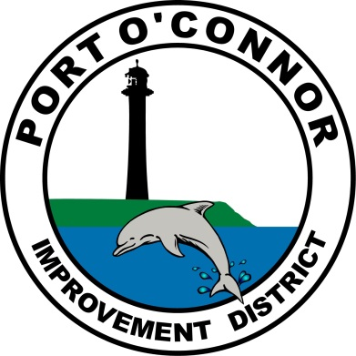  Note from the Board of Directors  The past year has been a busy one for Port O’Connor Improvement District. The first Board of Directors Election for the newly consolidate Port O’Connor Improvement District was called at the July 18, 2022 board meeting.  Accordingly, at its July regular board meeting, the Board took all necessary action and began the process of conducting an election for the positions of all five board members. As of the close of all filing timelines, only the existing five directors of Danny McGuire, Mike Clifton, Nathan O’Neill, John “Red” Childers, and Victor Mozisek had filed for re-election. As a result, all candidates are unopposed.  The District is authorized by law to cancel the election. The Board met and cancelled the election and declared each unopposed candidate elected to office. Each candidate is required to qualify for the office in the same manner as provided for a candidate as if elected. At the November board meeting, the directors will take their oaths of office, reorganize the board, and determine the terms of office for each director.  The Board encourages you to visit http://www.pocid.org to sign up for text and/or e-mail alerts that will allow Port O’Connor Improvement to deliver important news directly to your inbox or text app.  Nota de la Junta Directiva  El último año ha sido muy activo para el Distrito de Mejoras de Port O’Connor. La primera elección de Junta Directiva para el nuevo Distrito de Mejoras consolidado de Port O’Connor fue convocada en la asamblea de junta del 18 de julio de 2022.  Con este fin, en su asamblea ordinaria de julio, la Junta adoptó todas las medidas necesarias e inició el proceso de elección de los cinco miembros de la Junta. Al cierre de todos los plazos de presentación, sólo los cinco directores existentes, Danny McGuire, Mike Clifton, Nathan O’Neill, John “Red” Childers y Victor Mozisek habían presentado su candidatura par su reelección. Como resultado, ninguno de los candidatos tiene oponentes.  El Distrito está autorizado por ley para cancelar la elección. La Junta se reunió y canceló la elección y declaró electo a cada candidato sin oponentes. Cada candidato debe reunir los requisitos para el cargo de la misma manera que se establece para un candidato como si fuera elegido por votación. En la asamblea de noviembre, los directores tomarán juramento, reorganizarán la junta y determinarán los términos del cargo para cada director.  La Junta recomienda que visite http://www.pocid.org para inscribirse en alertas de texto y/o correo electrónico que permitirán a Mejoras de Port O’Connor enviar noticias importantes directamente a su bandeja de entrada o aplicación de texto.

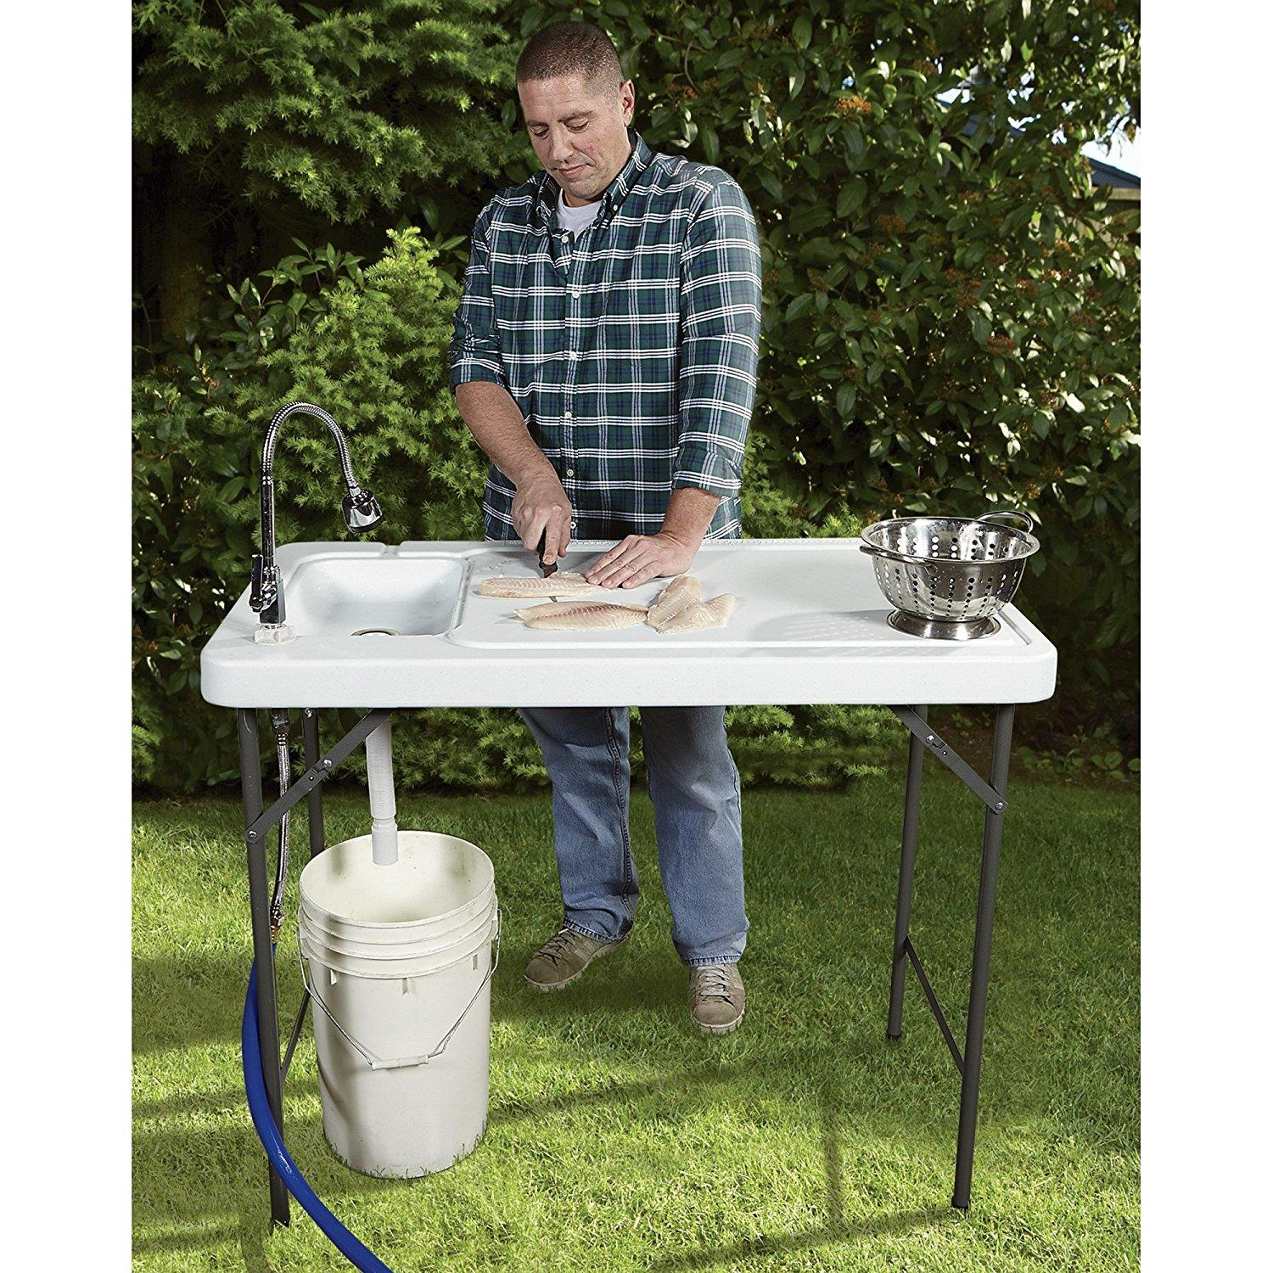
ALL Outdoor Showers and fish cleaning stations need a permit & an inspection per District Policy. We are actively identifying these to insure we do not have an excess of rainwater in our sewer system. The smoke testing did help us with these. Please
call the
District office @
361-983-2652 to obtain the required permit.

If you are closing your account, you must call the office and do so. You will continue to receive a bill until it is closed.
The buyer cannot close your account.
Auto Draft Fee Waived

Sign up for Auto Draft with your Bank Account for NO FEE!! Please note that if you use your Credit Card there is a 3.5% fee.

* Go to the website @ www.pocid.org - select Bill Payment and log in or set up an account and then select I want to set up auto pay.

* Go online to https://www.pocid.org/all-forms and select POCID ACH & Credit Card Form then fill out a form and email it to www.pocid@pocid.org

* Contact the Port O'Connor Improvement Office at 361-983-2652

Irrigation Permits
All sprinkler systems require a permit completed and turned in to the POCID Office before installation. After installation a backflow inspection is required.
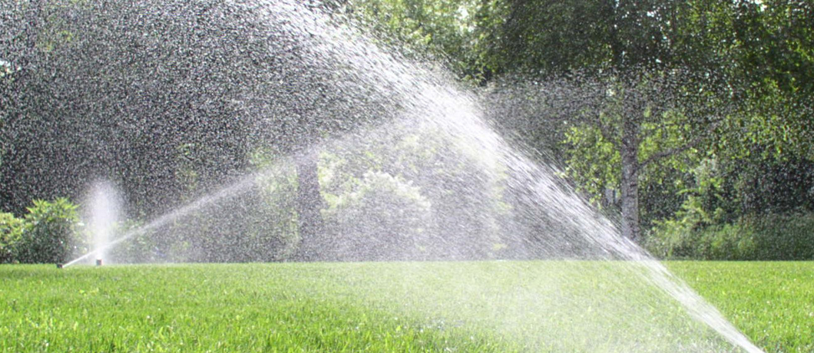
Check out our Website @ www.pocid.org
*Sign up for Alerts
* Pay your bill
* Applications/Forms
* Sign up for Auto Draft
* Current Projects
* Agendas/Minutes
* Updates
* Sign up for paperless billing

