|  |  |  |  |  |
| --- | --- | --- | --- | --- |
| |  | | --- | | Quarterly Newsletter  July 2024 | | |  | | --- | | Important Dates:  **POC Water Board Meetings are held on the third Thursday of each month @ 1pm**  *August 15th * September 19th * October 17th * November 21st*  **Roll off Trash Bin**  **First Saturday of each month behind the POCID Office from 8am -2pm or UNTIL FULL**  *September 7th * October 5th * November 2nd* | |   **Billing**  ***Bills are mailed by the 1st***  ***of each month and are due***  ***on 20th of every month***  ***and a late fee will be assessed***  ***on the 21st unless that falls***  ***on a weekend and then it***  ***will be due the following***  ***Monday.***  **Payment Methods:**  *Credit Card*Mail*Automatic*  *Bank Draft*Automatic Credit Card Draft*In Person*Payment Drop*  *Box* Bill Pay through your*  *Financial Institute*  Contact Us  POCID  39 Denman DR  PO Box 375  Port O’Connor, Texas 77982  361-983-2652  pocid@pocid.org  <https://www.pocid.org/>  <https://www.facebook.com/POCIDofficial/>  **Vision Statement**  *POCID is a proactive organization making a positive impact on the community while implementing best management practices to promote sustainable success.*  **Mission Statement**  *To proactively and efficiently*  *manage the affairs of the District*  *for the benefit of its customers,*  *protect the health of the community, produce safe drinking water in adequate quantities, offer*  *competitive rates, assure*  *financial stability, and practice excellence in customer service.* | “POCID”      ***\* Board of Directors District Kick-Off Shrimp Boil***    **Building to Serve You Better**  After the purchase of the GBRA 720 customer water system in July 2000, the District was officially in the water supply business. There were a lot of issues with the system the District was forced to buy as a condition of receiving the grant funds: (1) it was old—the pipes dated from the 1970s; (2) only a small portion of the District had service; (3) the water tower was out of compliance; (4) the system consisted primarily of two-inch pipe; (5) there were no fire hydrants in the GBRA system; and (6) the main water transmission line was in disrepair and traversed Boggy making it extremely difficult to detect and repair leaks.  Building the new $1.5 million 12-inch pipeline to transport potable water to Port O’Connor from the GBRA plant commenced immediately. Simultaneously, another pressing need was being met: the construction of a sewer collection system and treatment plant. By April 2001, the $5,200,000 sewer collection system and the treatment plant were online.  After these initial projects were operational, the focus was on old water system lines. The first improvements completed in December 2002 consisted of a new eight-inch water line on Byers and a new six-inch line on Conejo. Flush valves, fire hydrants, and new vacuum pits were also added. These additions increased the District’s customers to 744.  To further expand the system, several improvements were necessary: replacing the elevated tank, building a 500,000-gallon ground storage tank, and installing new booster pumps to improve storage and pumping capacity. These needs were financed with the 2004 Bonds. Anticipating this extra capacity, construction commenced in late 2005 on a $940,946 water project that added 35 fire hydrants, installed a new 12-inch line to the elevated tank, and added a new eight-inch waterlines on Byers and Harrison.  Over the next few years, expansion of the District’s water distribution and wastewater collection systems occurred in incremental steps as the budget allowed. The primary goals were to replace the two-inch lines where needed, add fire hydrants to areas, and expand the system to serve the entire District area. During that time, Director Tom Ekstrom would constantly advocate for “finding ways to put more pipe in the ground” to add and serve new connections, especially for the prepay clients. The first major wastewater collection system addition occurred in 2008 where 5,300 feet of eight-inch vacuum line was installed.  ***\* Construction of Ground Storage Tank * Construction of Elevated Storage Tank***    Expansion was necessary; the demand for the District’s services was high. By 2010 it was obvious the District was growing at a pace that necessitated formal, structured planning, input from professionals, and increased funding sources.  Brown & Gay Engineers was retained to analyze future demands on the District’s operations and develop an organized strategy for improvements and expansion through a Master Plan. Additional sources of revenue were also sought.  In 2013, the District, via SB 1822, changed its name to Port O’Connor Improvement District and obtained authorization to seek voter approval for the imposition of a sales tax (which passed on its second ballot placement).  Due to the failure of bond elections, the District implemented a significant rate increase during this time.    To meet the growing demand for water, and in conjunction with the former LaSalle WCID 1A—who paid for the construction and development of the well, the supplemental ground water well was developed.  Unfortunately, due to a high turnover in the Board of Directors, revolving employees, advisors, and professionals, most progress and maintenance halted from 2015 until 2019. When coupled with the increased population and demand for services during COVID, the result in 2020 was an overloaded, neglected, and problem-plagued system.  From 2020-22, the District was in catch-up mode. The new Board of Directors, with Erny McDonough as President, and members David Randolph, Maria Denney, Danny McGuire and Mike Clifton, vowed to unite and tackle the issues. Coupled with all the things needing immediate attention, GBRA informed the District of its intent to build a new water plant. The District’s scheduled share of costs for this new plant would necessitate a rate increase, for each customer, in excess of $60 a month. Studies into alternative water sources commenced. Due to health issues for some and an election, the Board changed; Danny McGuire assumed the role of President, and he and Mike Clifton were joined by Nathan O’Neill, Red Childers, and eventually Victor Mozisek. This new Board was extremely busy.  The years from 2020-2024 saw a lot of improvements, additions, and growth. In 2020, Phase I of the Master Plan’s water system improvements was completed, adding 43 fire hydrants along with eight-, six- and four-inch lines to a significant portion of the District. At the same time, 180 valves were installed to permit the isolation of sections of the water system when line breaks occur or maintenance is required. With these valve installations, the District no longer shuts off water to the entire town when an incident occurs. Also in 2020, approximately 730 feet of a new six-inch water line on 14th Street and 1,020 feet of a new six-inch water line on Polk Street were installed. |
| Growth clipart population increase, Growth population increase ...  *If you need to inform a District representative of something, request assistance with your water or wastewater system, want to report violations of the District’s Regulations, or have a general question, please call the main office. Calls directly to employees often lead to dropped documentation, an inefficient use of resources, interruption of services for others, or general confusion. Please route all calls through the main office at 361-983-2652.*  **CONTACT US 24/7**  For an after-hours problem or emergency please call the POCID Office at 361-983-2652 and a call will be dispatched to the on-call personnel.  Image result for aftrehours call out clip art | |  |  |  |  |  |  |  |  | | --- | --- | --- | --- | --- | --- | --- | --- | | **CALHOUN COUNTY JULY 2024 SALES AND USE TAX COMPARISON SUMMARY\*** | | | | | | | | | **City/County** | **Rate** | **Net Payment July** | **Comparable Payment Last Year** | **%Change** | **Payment YTD** | **Payment**  **Last Year YTD** | **% Change** | | Calhoun County | 0.500% | $ 372,571.20 | $ 337,224.82 | 10.48% | $ 2,316,647.30 | $ 2,204,349.48 | 5.09% | | Point Comfort | 1.00% | $ 24,928.51 | $ 14,725.83 | 69.28% | $ 145,272.85 | $ 108,989.69 | 33.29% | | Port Lavaca | 1.500% | $ 302,469.48 | $ 310,160.10 | -2.47% | $ 2,128,912.22 | $ 1,991,856.74 | 6.88% | | Seadrift | 1.500% | $ 24,459.00 | $ 27,892.10 | -12.3% | $ 185,120.65 | $ 197,871.90 | -6.44% | | POCID | 1.500% | $ 36,163.38 | $ 35,032.88 | 3.22% | $ 199,717.02 | $ 198,759.20 | 0.48% |   *Source Texas Comptroller as of July 23, 2024  Wastewater collection system improvements were also made in 2020: an additional force main on then vacuum station #2 was put on-line. Major sewer line upgrades recommended in the 2013 Master Plan were done: (1) Line A—5,200 feet of sewer line upsized; (2) Line B—1,466 feet upsized; (3) Line C –2,600 feet of line upsized; (3) Line D—5,120 feet; and (4) Line E—9 00 feet. Additionally, 5,000 feet of new lines and new pits were added. In 2021, Phase II of the Water Line Improvement Plan was implemented, and almost 20,000 feet of six-inch lines and 62 valves were installed along with 9 additional fire hydrants.  Major improvements to the sewer system were also made including the vent modifications and installation of air intakes to alleviate inflow issues.  The work continued in 2022 and 2023 when the District installed more water and sewer lines, switched to a Smart Meter system, refurbished and improved many facilities and fixtures including the generators, the elevated tank, and the ground storage tank. Expansion of the vacuum stations was undertaken to accommodate increased demand and plan for future growth. The District held a bond election approving the issuance of $40 million in bonds to finance current and planned future improvements and decided to pursue water independence via the reverse osmosis of groundwater.  Meanwhile, the GBRA plant sold to a for profit entity, Undine, and water contracts were renegotiated for an interim water supply.  The increased cost of water for this interim supply is being absorbed by the District rather than being passed on to the customers. In preparation for the water source change that will occur in 2025, a new ground storage tank was erected, permits were obtained from the Calhoun County Groundwater Conservation District for the well field, wells are being developed, the building to house the RO system is being erected, and the RO system is currently being manufactured.  Progress has not slowed down in 2024; water and sewer projects continue.  The Board is considering upgrades to the sewer system controls, expansion of the wastewater plant, the installation of another force main to maximize the efficient operation of the lift station improvements and new sewer lines to accommodate areas of new growth in the District. The Board has realized people are going to come to the area regardless of the capacity of the District’s facilities. The goal is to avoid the chaos of playing catch up. The vow: to leave the District prepared for the demands of current and future customers.  The Board thanks everyone for their support, trust, and patience in navigating these last five years of extreme catch up, expansion, improvements, growth and new systems. |
|  | **Current Project Update**   1. **Sanctuary Water Plant Rehab** is complete and fully   operational.  2) **Vac Station on 13th Street** is complete and operational.  3) **Vac Station on Monroe**       Building Foundation and Vault are complete.       Generator has been installed.       Vac Station components are being manufactured.        Building materials are on site and once vac station  components are installed building will be erected.  4) **RO System**        Yard plumbing, electrical and control conduits are installed.        Building shell and skin for RO System has been installed.       RO system components are being manufactured.   5) **Raw Water Wells**       Wells 3, 5, 6, and 7 have been drilled and are ready for  pumps.  6) **Well Collection Lines and RO Discharge**       Collection and RO lines are installed and will be connected to  pumps as well contractor installs pumps at wells 3, 5, 6 & 7.        Well platforms are being placed at this time.   7) **Raw Water Ground Storage Tank**       Tank is complete; contractor will clean and button up the  tank by the end of August.      Collection Line Contractor will connect well lines to the tank. |

**Having problems flushing?**

Open or broken clean outs during rain events create problems in the system for everyone. If it’s you…Fix it! If it’s your neighbor call and let us know.

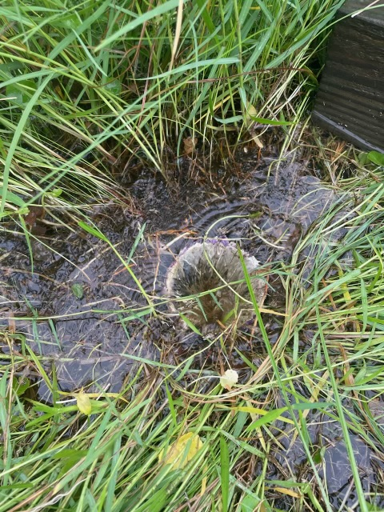

**Irrigation Permits**

**All sprinkler systems require a permit completed and turned in to the POCID Office before installation. After installation a backflow inspection is required.**



Check out our Website @ [www.pocid.org](http://www.pocid.org)

**\*Sign up for Alerts**

**\* Pay your bill**

**\* Applications/Forms**

**\* Sign up for Auto Draft**

**\* Current Projects**

**\* Agendas/Minutes**

**\* Updates**

**\* Sign up for paperless billing**

**POCID Rules and Regulations require all customers to have a customer service valve outside their meter box within 3 feet of the meter box.**

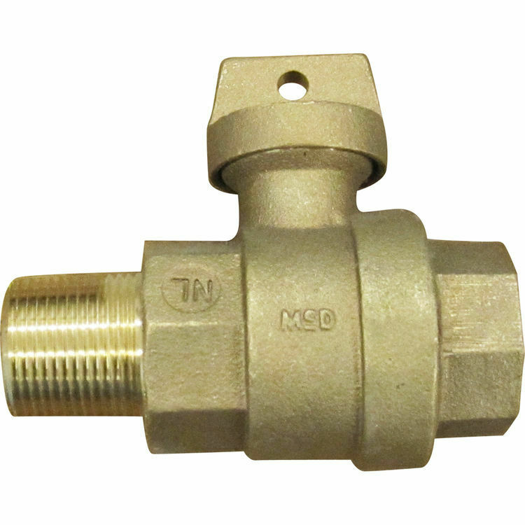



**Auto Draft Fee Waived**

Sign up for Auto Draft with your **Bank Account** for **NO FEE**!! **Please note that if you use your Credit Card there is a 3.5% fee.**

* Go to the website @ [www.pocid.org](https://l.facebook.com/l.php?u=http%3A%2F%2Fwww.pocid.org%2F%3Ffbclid%3DIwAR1RcLWgEPAebm-ZNp70EGMkdf6QCoy3I49g8QBfZVBynTieC7M20Sd3RQk&h=AT1Prcf9xoYbUFAOUcPOxbg7MUs3wGQteTOXAnPb0XsyQCf_6nsq8S0ZLhR6gLylSJ80jN-WzzwV6QRPV52KfYSAijxP7_rrHN-19yrmajQQWAYzCSAZEvriyvu3Vy86IA&__tn__=-UK-R&c%5b0%5d=AT0It4OKA8z8brbuTEnJqAzCMRBHMWLw_RM2miWdY3o9svX_12_RvDSSq26YlU-s4v5tTlpPMHOUpK6s8jjULL9C2sIy7JIpjBjH7NA7aYPhlrnfv6gpcwlxJ7UoVdNXPbOcIl0SqPXJ6ooseBqevuzRmBexfu8PNPwqE-P6XUSBxA) - select Bill Payment and log in or set up an account and then select I want to set up auto pay.

* Go online to [https://www.pocid.org/all-forms](https://www.pocid.org/all-forms?fbclid=IwAR0ESAVw63Q2_aWjDFNmgcVcvFVRqAQk7sO08dwwTp0zozGdy7qZCfYrRZc) and select POCID ACH & Credit Card Form then fill out a form and email it to [www.pocid@pocid.org](http://www.pocid@pocid.org)

* Call 844-923-2162 and pay your bill by phone 24/7

* Contact the Port O'Connor Improvement Office at 361-983-2652



