|  |  |  |  |  |
| --- | --- | --- | --- | --- |
| |  | | --- | | Monthly Newsletter  April 2021 | | |  | | --- | | Important Dates:  **POC Water Board Meetings are held on the second Thursday of each month @ 1pm**  *April 15 * May 13*  **Roll off Trash Bin**  **First Saturday of each month behind the POCID Office from 8am -2pm or UNTIL FULL**  *April 10th * May 1st* | |   **Billing**  ***Bills are mailed by the 1st***  ***of each month and are due***  ***on 20th of every month***  ***and a late fee will be accessed***  ***on the 21st unless that falls***  ***on a weekend and then it***  ***will be due the following***  ***Monday.***  **Payment Methods:**  *Credit Card*Mail*Automatic*  *Bank Draft*Automatic Credit Card Draft*In Person*Payment Drop*  *Box* Bill Pay through your*  *Financial Institute*  Contact Us  POC Water  39 Denman DR  PO Box 375  Port O’Connor, Texas 77982  361-983-2652  pocmud@tisd.net  <https://www.pocid.org/>  <https://www.facebook.com/POCIDofficial/>  **Vision Statement**  *POCID is a proactive organization making a positive impact on the community while implementing best management practices to promote sustainable success.*  **Mission Statement**  *To proactively and efficiently*  *manage the affairs of the District*  *for the benefit of its customers,*  *protect the health of the community, produce safe drinking water in adequate quantities, offer*  *competitive rates, assure*  *financial stability, and practice excellence in customer service.* | **“POC Water”**    **P.O. Box 375/ 39 Denman Dr**  **Port O’ Connor, Texas 77982**  **Phone: (361) 983-2652**  Flushing a fire hydrant also allows district workers to test its efficiency. Fire hydrants are, of course, used to fight fires, and the district needs to be sure that they will have enough water pressure and flow if the fire department were to need it.  The biggest reason why a fire hydrant would be flushed is to clear out any stagnant water that may be sitting in the district’s pipes. When water is pumped through POCID pipelines, it is treated with chlorine to keep bacteria from thriving in it. While this does work reasonably well, the chlorine in water degrades over time and becomes less effective. Flushing water from a hydrant removes the degraded chlorine and any polluted water from the district’s water system. It also helps to clear out any sediment and other contaminants that could have settled within the water as POCID pipes age and start to degrade. In other words, water needs to keep flowing if it is going to be safe for drinking or washing, and flushing a fire hydrant allows that to happen.  .  **Flushing……WHY???**  You’ve probably seen open fire hydrants at some point spraying water all over the street. If you didn’t know exactly what was going on, you might think the hydrant is damaged and needs to be repaired or someone working for the district is wasting a lot of water. Maybe you were just annoyed at having to walk around a fire hydrant that is spraying gallons of water everywhere. It turns out that there is a good reason why a fire hydrant might be left open like this. It seems wasteful and somewhat obnoxious, but hydrant flushing is an important job.    See the source image  **Happy Easter from your friendly POCID Crew!**    **PROJECT UPDATE**  **TWDB Project No. 21750**  All the work that was originally designed by Brown and Gay and the work from change orders to the project has been completed.   The balance of the funds remaining are being used to perform a valve & hydrant inventory & evaluation.  **2018 TWDB Projects**  **Completed projects**  Vacuum Station No. 2 Force Main  Vacuum Sewage Collection System Upgrade  Phase II Water System Improvements  **Ongoing projects:**  **Phase III Water & Sewer System Improvements**  Miscellaneous water & sewer improvements designs are complete & plans & specs were sent to TCEQ for approval.  **2020 TWDB DW SRF Bond Projects**  Final environmental submittals have been made to TWDB.   TWDB has indicated that it will be the first part of 2021 before their review and approval will be completed.  The projects cannot be put out for bids until TWDB has approved all the environmental.  A public hearing on the environmental was held on December 10, 2020.  New Water Wells  The plans for the water wells have been completed and approval from TCEQ was received by letter dated 6/22/20.  A resubmittal for the new Well No 7 has been summitted to TCEQ for approval of the new well location. The proposed water wells will be summitted to the Calhoun County GCD for drilling & operation permits at their next available meeting.  Well Transmission Lines and RO Outfall  The plans for the well lines and RO discharge line are nearing completion subject to a revision to include the line to the new Well No. 7 location.   Plans have been summitted to TCEQ for review & approval.  Raw Water Ground Storage Tank  The plans and specifications for this project are complete and were approved by TCEQ by letter dated 6/2/20.  A revised submittal is being developed for a larger raw water storage tank based on design re-consideration with the inclusion of LaSalle to the water distribution system. Formal approval will not be given by TWDB until all environmental conditions have been met.  Reverse Osmosis Treatment Facility  Design for this major project is proceeding. This is a major design project that includes a building, equipment, piping, electrical, controls, HVAC and chemical treatment.  The original design concept is being modified due to the inclusion of LaSalle to the system. The RO capacity has been increased & the building has been increased in size to accommodate the additional equipment.  None of the 2020 Bond projects can be bid until all the environmental and permitting has been completed and approved by TWDB.  For TWDB to approve the completed Environmental Document the following are required.   * Final design of all project components (See individual Project status above) * Engineering Feasibility Report (Completed and in Application) * Public meeting (held on Dec 10)   There will then be an approximate three-month time for review and approval by TWDB, provided there are no major problems with any of the submittals.  Because the wells will take the longest time for approval, at least 60 days after they are completed, the wells will be the first project of the 2020 Bond fund projects to bid.  Bidding of the other projects will be staged as appropriate depending on the time required for completion of the wells and to minimize on-site conflicts with multiple projects and contractors.  **Elevated Storage Tank**  This has been placed on hold until completion of the District Master Plan in order to better determine the needs of the District for water storage facilities.  **Easement acquisitions**  An exception to the sanitary control easement area that falls within the TXDOT RROW for SH185 still must be obtained from TCEQ. The revised and enlarged R/O outfall line easement has been obtained.  The sanitary control easement necessary for Well #7 has been drafted and is awaiting execution. |

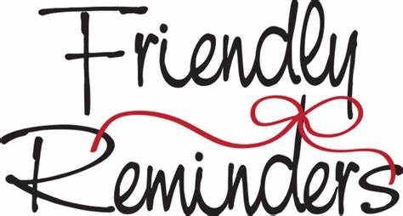



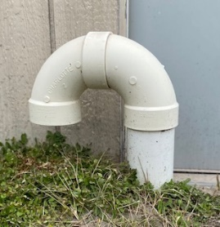



**Customer Service Valve**

**Remember to install a customer service valve on your side of the meter. Please turn your customer service valve off if you live out of town to keep any water leaks turning into a disaster. Turning on/off the POCID meter is against District Policy.**

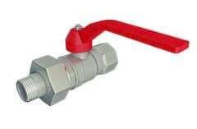

Check out our Website @ [www.pocid.org](http://www.pocid.org)

**\*Sign up for Alerts**

**\* Pay your bill**

**\* Applications/Forms**

**\* Sign up for Auto Draft**

**\* Current Projects**

**\* Agendas/Minutes**

**\* Updates**

**\* Sign up for paperless billing**

**Customer Service Valve**

**DEADLINE APRIL 12th**

The Port O’Connor Improvement District will be proceeding with the implementation of our Advanced Metering Infrastructure (AMI) in the near future.

While converting from the old meters to the new ones we are offering our customers the opportunity to add the required cut-off valve on the customer’s side of the service line.

If you would like for the District to install this Customer Service Valve please contact the POCID Office. The fee for the installation of the Customer Service Valve is $125.00. A signed customer payment agreement will be required to add this cost to your bill. **The deadline for this is APRIL 12th.**

Once the Customer Service valve is installed it becomes the property of the customer and they are responsible for maintaining it.

**YOU DON’T NEED THIS**



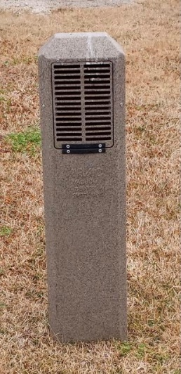

**Is your account a TEMP account? Call us to schedule a for Customer Service Inspections (CSI) to be in compliance with the state. This is to make sure you don't have any lead pipes or cross connections.**





**POC Water**

**PO Box 375/39 Denman Dr**

**Port O’Connor, TX 77982**

**361-983-2652**

