- Monthly Newsletter  December 2020  Important Dates:  POC Water Board Meetings are held on the second Thursday of each month @ 1pm  December 10th * January 14th  Roll off Trash Bin  First Saturday of each month behind the POCID Office from 8am -2pm or UNTIL FULL  December 5th * January 9th  Billing  Bills are mailed by the 1st  of each month and are due  on 20th of every month  and a late fee will be accessed  on the 21st unless that falls  on a weekend and then it  will be due the following  Monday.  Payment Methods:  Credit Card*Mail*Automatic  Bank Draft*Automatic Credit Card Draft*In Person*Payment Drop  Box* Bill Pay through your  Financial Institute  - Contact Us  POC Water  39 Denman DR  PO Box 375  Port O’Connor, Texas 77982  361-983-2652  pocmud@tisd.net  https://www.pocid.org/  https://www.facebook.com/POCIDofficial/  Vision Statement  POCID is a proactive organization making a positive impact on the community while implementing best management practices to promote sustainable success.  Mission Statement  To proactively and efficiently  manage the affairs of the District  for the benefit of its customers,  protect the health of the community, produce safe drinking water in adequate quantities, offer  competitive rates, assure  financial stability, and practice excellence in customer service. | “POC Water”  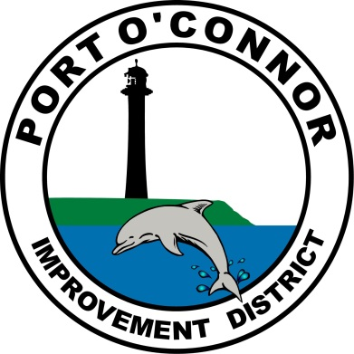  P.O. Box 375/ 39 Denman Dr  Port O’ Connor, Texas 77982  Phone: (361) 983-2652  Where does our water come from?  Living in a coastal community, water is seemingly everywhere. Everywhere you look you see water. We drink water, bathe in it, and cook with it. We just turn on a faucet and water is there to meet our daily needs. Our easy access to water makes it appear nearly limitless. Although water comprises 70% of Earth, only one percent of water is fresh & usable. This 1% of water comes from lakes and rivers or the ground. Your water either comes from a public source (POCID) or from a private source (wells). For public health & safety, POCID water is treated before it reaches your faucet. Water treatment involves the removal of impurities that make water unsafe for human consumption.  For POCID water supply, there are currently two water sources. Surface water (water from a lake, pond, river or stream) is diverted from the Guadalupe River & pumped to the GBRA water treatment plant. There, licensed operators treat the water by settling and filtering out suspended solids, dirt, and other organic particles until the water reaches a crystal-clear quality. A disinfectant compound of chlorine & ammonia is used to destroy any pathogens (germs)present. The second source is a ground water well in POC. The ground water is blended with the water received from GBRA. Additional treatment for the groundwater from the well is performed by POCID on the district’s premises.  Future Plans of POCID Water  GBRA is going to update its current plant that serves Port Lavaca, Rural Water and POCID. POCID is evaluating the capacity it will need in the projected new plant. This capacity determines the cost POCID will bear going forward to service the debt attributed to the plant update. The timeline for this update keeps getting pushed back; however, POCID is moving forward with plans to meet the District’s future water needs.  The Board of Directors has decided the most feasible & economic way to provide for the District’s future water supply is to drill five new wells for a total of six operational wells. This supply should be more than adequate, based on current calculations of future needs, to meet the 2039 projected required water capacity of POCID. POCID will also construct a Reverse Osmosis (RO) treatment facility. The projected cost of the new wells and RO treatment facility is approximately $5.8 million dollars. The District considered several options available to fund these improvements. The Board of Directors decided issuing the six million dollars in preapproved tax bonds was the best course of action. The District’s Financial advisers have analyzed the tax base, anticipated tax revenue and have instructed the Board due to projected growth (barring any natural disaster resulting in significantly lower tax values), it is anticipated that the future tax increase, if any, will be minimal. The District was recently notified it will be awarded 6 million in low interest loans from the Texas Water Development Board to fund this water supply project. The loan closing date will be early spring 2021.  Thank You Erny McDonough & Maria Denney for your Service on the POCID Board!  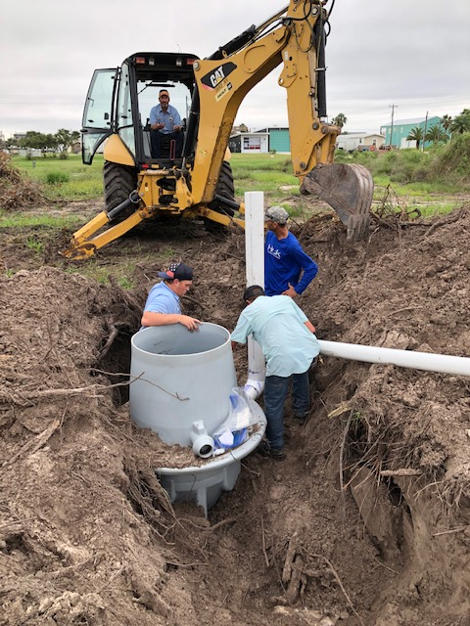  POC Water employees installing a pit  UPDATES  Texas Water Development Board Project 21750 All work originally designed by Brown & Gay and all work from change orders to the project has been completed. There is a balance of funds remaining that will be added to the contingency funds of the 2020 TWDB bond project.  2016 TWDB Projects The New Vacuum Station 2 Force Main & Vacuum Sewage Collection System improvements have been completed. R & A Road Boring LLC out of Houston has begun the Phase II Water System Improvements Project and have not experienced any setbacks. This project will install approximately 16,700 feet of new 6-inch water line and nine fire hydrants.  Future water and/or sewer projects are being considered to further enhance and improve the water supply and distribution system and the sewage collection system.  2020 Texas Water Development Board Project Updates The plans for the new water wells and the connecting water lines are nearing completion as are the plans for a new raw water ground storage tank to be constructed at the Denman Road plant. Design of the reverse osmosis treatment facility is progressing. The archeological survey has been completed. Upon completion of all of the environmental and permitting for the projects in the first quarter of 2021, and pending TCEQ timely approval, construction of the projects should begin in mid-2021.  Welcome to the team  New POCID Board of Directors  Nathan O’Neill & John “Red” Childers  Merry Christmas from  POC Water!  POC Water Office will be closed Thursday, December 24th and Friday, December 25th to celebrate Christmas with our families.  If you have an EMERGENCY please call 361-983-2652  and the answering service will send someone out.
Please post your correct 911 address on your house. This is not just to help POCID but if you need EMS, fire or any other Emergency Care. Thank you for your assistance with this.

Port O'Connor Improvement District secures $6 million loan for water system expansion
Victoria Advocate By Kali Venable | kvenable@vicad.com Nov 5, 2020
The Texas Water Development Board approved a $6 million loan on Thursday for the Port O’Connor Improvement District to expand its use of local groundwater.

By building at least five new water wells, connecting water lines to a new raw water storage tank and treatment facility, the district plans to become less dependent on the Guadalupe-Blanco River Authority’s surface water treatment plant in Calhoun County.

District general manager Phillips Givens said the project will save money and create a more reliable water source for its growing customer base.

In 2018, GBRA told Port Lavaca and Port O’Connor that the state was requiring it to build a new water treatment plant in Calhoun County to address growth and cut down on disinfecting the water with byproducts such as chlorine, which the Environmental Protection Agency says can cause cancer.

All GBRA clients, including the district, will have to help pay for the new plant directly dependent on how much water they use.

The district purchases about 20% of the GBRA plant’s treated water capacity and plans to negotiate a new contract to reduce that amount, according to TWDB records.

“It is a way to address the increase in demand, but also try to maintain a lower cost of providing the water to residents so they won’t have a big shock to their water bills,” Givens said.
Under the expansion plan, district customers will not see an increase in rates and fees for water and wastewater because revenue that is generated to pay off the loan comes from property taxes.
Based on the district’s most recent financial analysis, the board also has no plans for increasing tax rates as a result of the $6 million loan because the district is pledging tax money that is already being collected, Givens said.

The reduced dependence on the GBRA plant is projected to save the district “a significant” amount of money, Givens said. The exact figure was not available, though last year board member Danny Shane McGuire told the Advocate that the project would allow the district to pay about $5.8 million instead of $10.8 millin for its contribution to the new plant.

Those figures are subject to change because while the new plant has been discussed for years, little progress has been made toward building it.

The Port Lavaca City Council last discussed the prospect of moving forward with the plans during a workshop at the end of September, but took no action. The city uses more than half of the GBRA plant’s treated water capacity.

Patty Gonzales, a GBRA spokeswoman, said the authority supports the district’s efforts to expand and diversify its water supply and will continue to supply the district a sustainable source of treated surface water as needed.

“Should POCID reduce its contracted water amount required from the plant, GBRA will make any needed design adjustments to the new plant,” she said.

The new wells and water lines will nearly double the Port O’Connor Improvement District’s net water supply to 2.56 million gallons per day, according to TWDB.

Givens said the construction process is expected to start by the middle of 2021, but is dependent on the timeline for approval from the Texas Commission of Environmental Quality, the completion of a required environmental impact assessment and the construction bidding process.

The well water will be discharged into a new ground storage tank and treated by a new reverse osmosis treatment facility to meet TCEQ standards. Treated water will then flow into the existing ground storage tank and be blended with water from the GBRA plant before being pumped through distribution lines.

Reverse osmosis is a filtering process that uses engineered membrane material to remove dissolved organic materials, viruses, bacteria and other contaminants from water. The process can also remove salts such as those found in the aquifers along the Gulf Coast.

“Long term, your own groundwater source is more reliable and surface water has a higher treatment cost,” Givens said. “If the projects hold true in terms of the growth of the community … as that demand grows, we’re going to rely more and more on the groundwater than we are on GBRA.”

lead pipes or cross connections.
Make sure you have hose bib vacuum breakers on all your outside faucets!

We are scheduling appointments for Customer Service Inspections (CSI) to be in compliance with the state. This is to make sure you don't have any
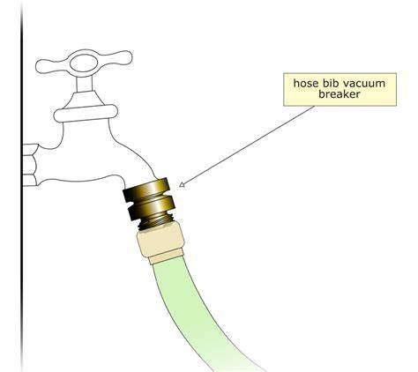
Check out our Website @ www.pocid.org
*Sign up for Alerts
* Pay your bill
* Applications/Forms
* Sign up for Auto Draft
* Current Projects
* Agendas/Minutes
* Updates
* Sign up for paperless billing

Customer Service Valve
Remember to install a customer service valve on your side of the meter. Please turn your customer service valve off if you live out of town to keep any water leaks turning into a disaster. Turning on/off the POCID meter is against District Policy.
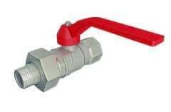

November 2020
POCID Board Members

President – Danny McGuire

Vic President – Mike Clifton

Secretary- Nathan O’Neill

Director – John “Red” Childers

Director – David Randolph
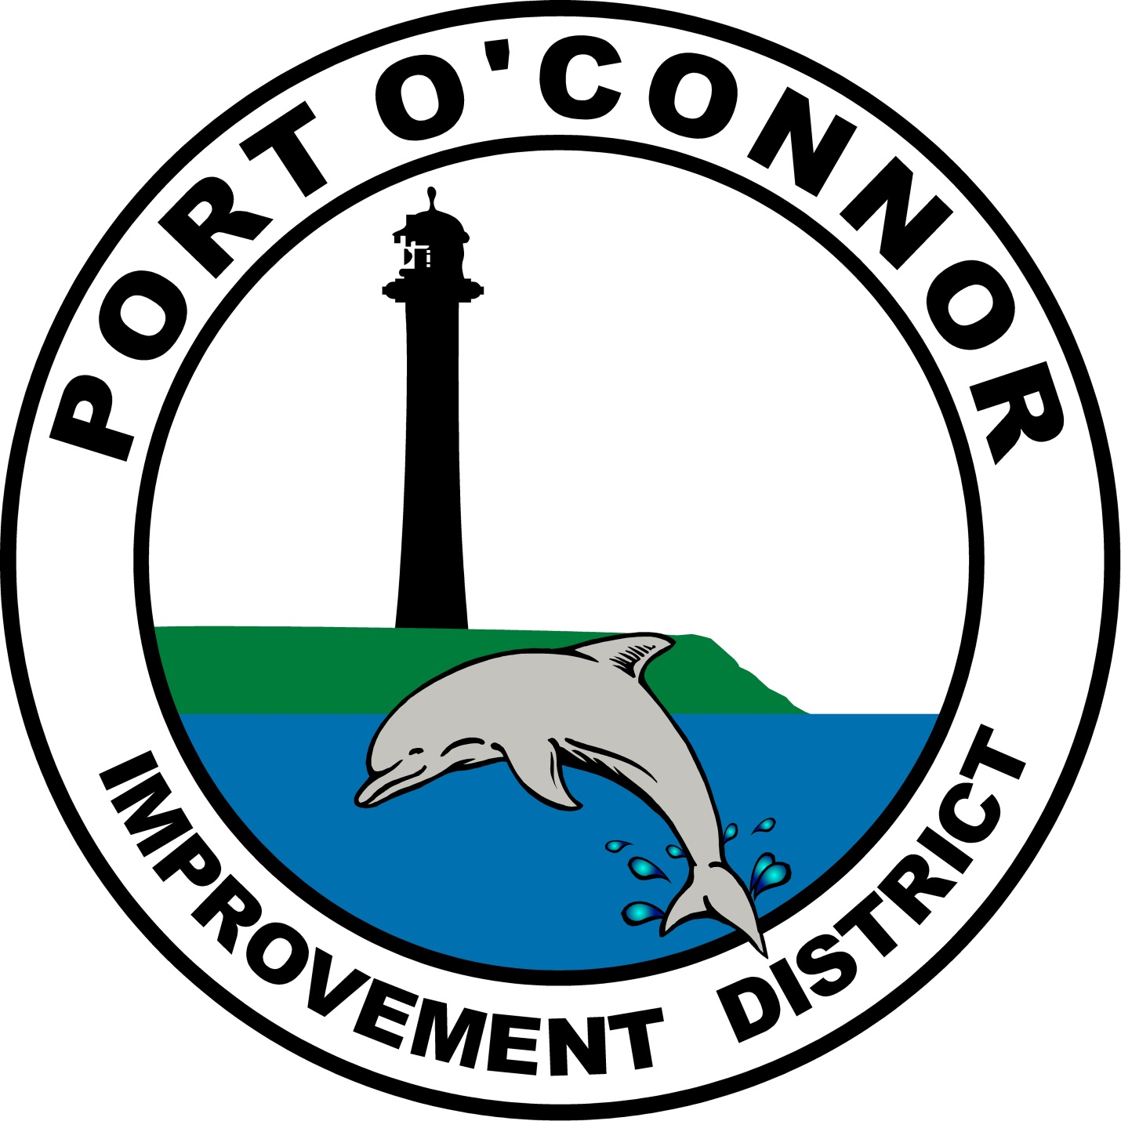
POC Water
PO Box 375/39 Denman Dr
Port O’Connor, TX 77982
361-983-2652

