- Monthly Newsletter  May 2021  Important Dates:  POC Water Board Meetings are held on the second Thursday of each month @ 1pm  May 13 * June 10th  Roll off Trash Bin  First Saturday of each month behind the POCID Office from 8am -2pm or UNTIL FULL  May 1st * June 5th  Billing  Bills are mailed by the 1st  of each month and are due  on 20th of every month  and a late fee will be accessed  on the 21st unless that falls  on a weekend and then it  will be due the following  Monday.  Payment Methods:  Credit Card*Mail*Automatic  Bank Draft*Automatic Credit Card Draft*In Person*Payment Drop  Box* Bill Pay through your  Financial Institute  - Contact Us  POC Water  39 Denman DR  PO Box 375  Port O’Connor, Texas 77982  361-983-2652  pocmud@tisd.net  https://www.pocid.org/  https://www.facebook.com/POCIDofficial/  Vision Statement  POCID is a proactive organization making a positive impact on the community while implementing best management practices to promote sustainable success.  Mission Statement  To proactively and efficiently  manage the affairs of the District  for the benefit of its customers,  protect the health of the community, produce safe drinking water in adequate quantities, offer  competitive rates, assure  financial stability, and practice excellence in customer service. | “POC Water”  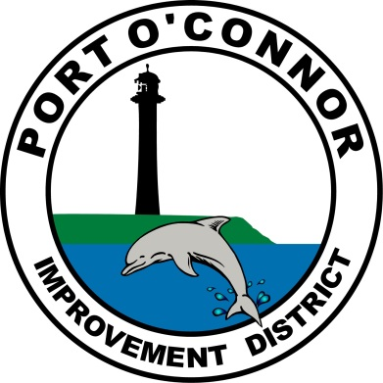  P.O. Box 375/ 39 Denman Dr  Port O’ Connor, Texas 77982  Phone: (361) 983-2652  In February of 2021 Misty Richter was hired to fill this position. Misty is a “home town” girl and has already demonstrated how much of an asset she is to the POCID family. Misty worked for CCISD for 13 years and volunteered as 4H Manager for the last 3 years. In her free time, she loves spending time with her family and her puppies.  She has been working alongside our District Manager, Oscar Pena, to foster an environment where compliance and ethics are second nature.  New Team Member  As we continue to seek ways to improve our services to the community the POCID decided to add a Compliance Technician position to our operations crew. As many of you know, during the last few years POCID has had issues with inflow and infiltration into our sewer system. The District has been working diligently on these issues and this addition of personnel will allow for better monitoring and corrective actions when necessary. Other duties assigned to this position are the coordination between the District and our residents due to all the Water and Sewer system upgrades and changes going on in Port O’Connor.  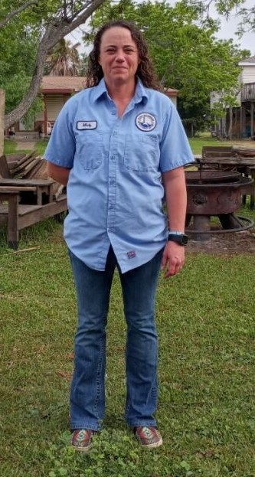  .  Remembering all our Heroes who paid the ultimate price!  The POCID Office will be closed Monday, May 31st.  PROJECT UPDATE  TWDB Project No. 21750  All the work that was originally designed by Brown and Gay and the work from change orders to the project has been completed. The balance of the funds remaining are being used to perform a valve & hydrant inventory & evaluation.  2018 TWDB Projects  Completed projects  Vacuum Station No. 2 Force Main  Vacuum Sewage Collection System Upgrade  Phase II Water System Improvements  Ongoing projects:  Phase III Water & Sewer System Improvements  Miscellaneous water & sewer improvements designs are complete & plans & specs were sent to TCEQ for approval.  2020 TWDB DW SRF Bond Projects  Final environmental submittals have been made to TWDB. TWDB has indicated that it will be the first part of 2021 before their review and approval will be completed. The projects cannot be put out for bids until TWDB has approved all the environmental. A public hearing on the environmental was held on December 10, 2020.  New Water Wells  The plans for the water wells have been completed and approval from TCEQ was received by letter dated 6/22/20. A resubmittal for the new Well No 7 has been summitted to TCEQ for approval of the new well location. The proposed water wells will be summitted to the Calhoun County GCD for drilling & operation permits at their next available meeting.  Well Transmission Lines and RO Outfall  The plans for the well lines and RO discharge line are nearing completion subject to a revision to include the line to the new Well No. 7 location. Plans have been summitted to TCEQ for review & approval.  Raw Water Ground Storage Tank  The plans and specifications for this project are complete and were approved by TCEQ by letter dated 6/2/20. A revised submittal is being developed for a larger raw water storage tank based on design re-consideration with the inclusion of LaSalle to the water distribution system. Formal approval will not be given by TWDB until all environmental conditions have been met.  Reverse Osmosis Treatment Facility  Design for this major project is proceeding. This is a major design project that includes a building, equipment, piping, electrical, controls, HVAC and chemical treatment.  The original design concept is being modified due to the inclusion of LaSalle to the system. The RO capacity has been increased & the building has been increased in size to accommodate the additional equipment.  None of the 2020 Bond projects can be bid until all the environmental and permitting has been completed and approved by TWDB. For TWDB to approve the completed Environmental Document the following are required.  - Final design of all project components (See individual Project status above)  - Engineering Feasibility Report (Completed and in Application)  - Public meeting (held on Dec 10)  There will then be an approximate three-month time for review and approval by TWDB, provided there are no major problems with any of the submittals.  Because the wells will take the longest time for approval, at least 60 days after they are completed, the wells will be the first project of the 2020 Bond fund projects to bid. Bidding of the other projects will be staged as appropriate depending on the time required for completion of the wells and to minimize on-site conflicts with multiple projects and contractors.  Elevated Storage Tank  This has been placed on hold until completion of the District Master Plan in order to better determine the needs of the District for water storage facilities.  Easement acquisitions  An exception to the sanitary control easement area that falls within the TXDOT RROW for SH185 still must be obtained from TCEQ. The revised and enlarged R/O outfall line easement has been obtained. The sanitary control easement necessary for Well #7 has been drafted and is awaiting execution.

Beginning around June 7th, Vanguard will begin installing AMI meters. For the POC residents that chose to have us install a new customer service valve, they will be installing those at the same time.
The District is very excited to bring this to POC. The endpoint for the meter signal is mounted on the lid and connected to the meter with a small cable. Please refrain from going into the meter box to prevent any possible damage.

LETTER FROM
THE DISTRICT MANAGER

In July, I will have served the community of Port O’Connor for 2 years. As the person responsible for the POCID water and sewer systems, my goal from day one has always been to provide our residents with the best service possible in the most efficient and courteous manner. We are always receptive to input from the community, positive or negative, as this helps us provide you the service you deserve.

Port O’Connor continues to grow and with it so does the infrastructure necessary to accommodate the growth. In the next few months, we will be extending water and sewer to areas that currently have none, installing an Automated Meter Infrastructure (AMI) System, and rehabilitating our Elevated Storage and Ground Storage tanks.
We look forward to getting these projects completed with as little disruption as possible to the residents of POC.

Customer Service Valve
Remember to install a customer service valve on your side of the meter. Please turn your customer service valve off when you are not occupying your residence to keep any water leaks from turning into a disaster. Turning on/off the POCID meter is against District Policy.
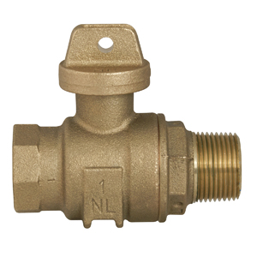

Check out our Website @ www.pocid.org
*Sign up for Alerts
* Pay your bill
* Applications/Forms
* Sign up for Auto Draft
* Current Projects
* Agendas/Minutes
* Updates
* Sign up for paperless billing

POC Water
PO Box 375/39 Denman Dr
Port O’Connor, TX 77982
361-983-2652

